Discover Malaysia with INTRO TRAVELS INDIA
Malaysia is one of Southeast Asia’s most beautiful and diverse travel destinations, famous for modern cities, tropical islands, rainforests, cultural heritage, luxury shopping, and delicious food. From the iconic skyline of Kuala Lumpur to the crystal-clear beaches of Langkawi, Malaysia offers the perfect mix of adventure, relaxation, and culture.

Why Visit Malaysia?
- Modern cities with world-famous landmarks
- Beautiful tropical islands & beaches
- Affordable luxury travel
- Rich multicultural heritage
- Delicious Malaysian cuisine
- Adventure activities & nature tours
- Family-friendly attractions
- Great shopping destinations

Top Tourist Attractions in Malaysia
1. Kuala Lumpur – The Vibrant Capital
Malaysia’s capital city is famous for skyscrapers, shopping malls, nightlife, and cultural attractions.
Top attractions:
- Petronas Twin Towers
- KL Tower
- Bukit Bintang shopping district
- Chinatown & Central Market
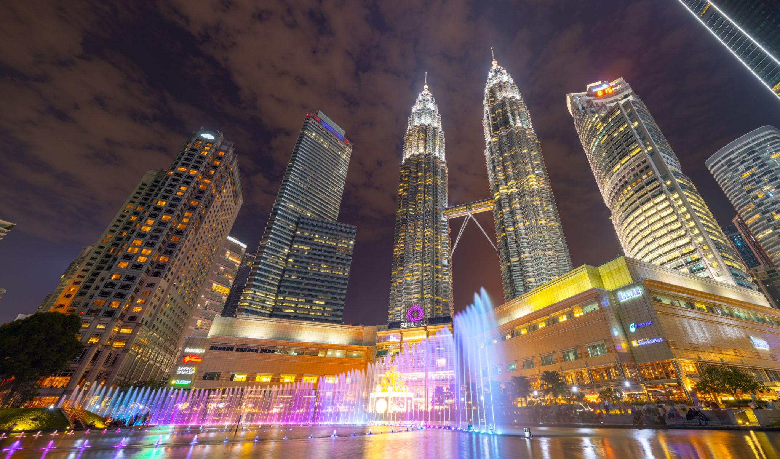
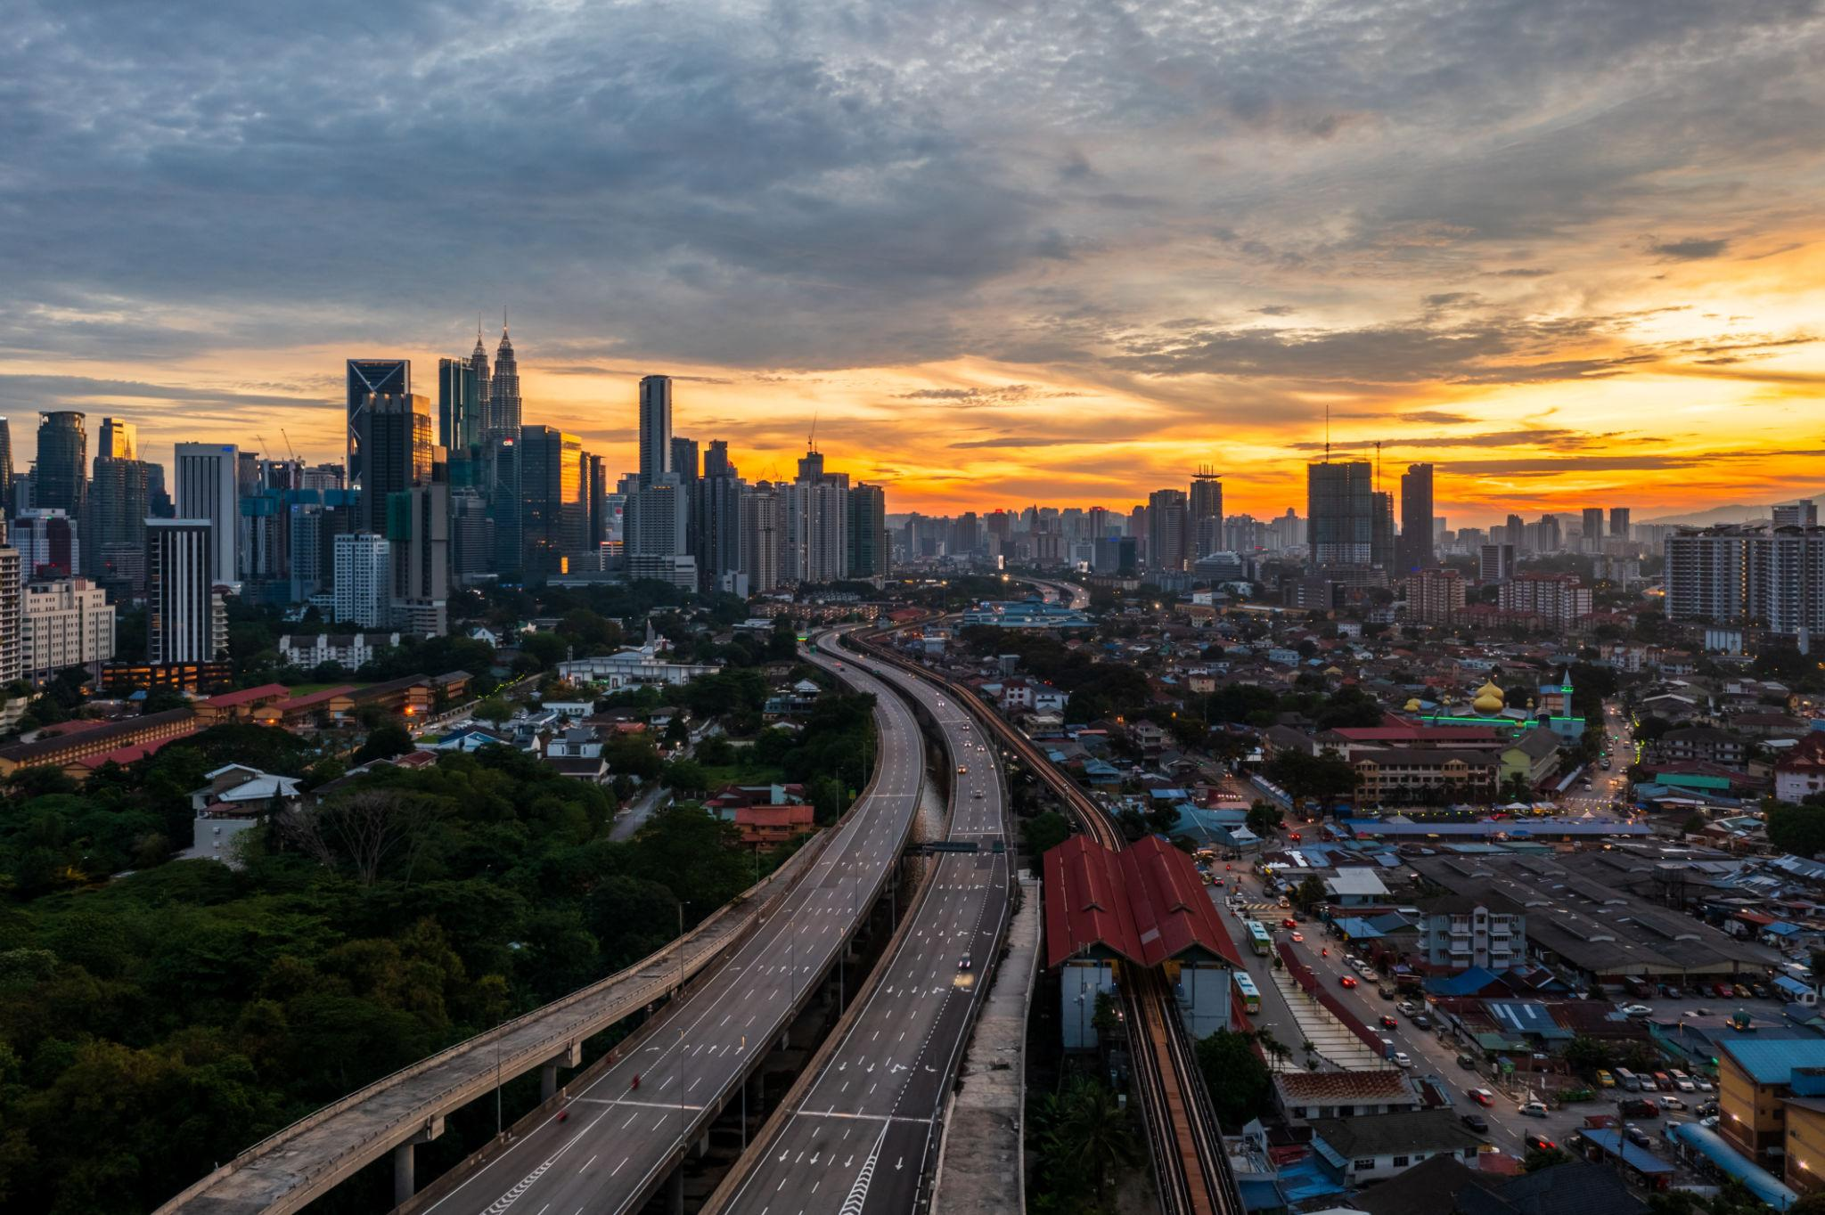

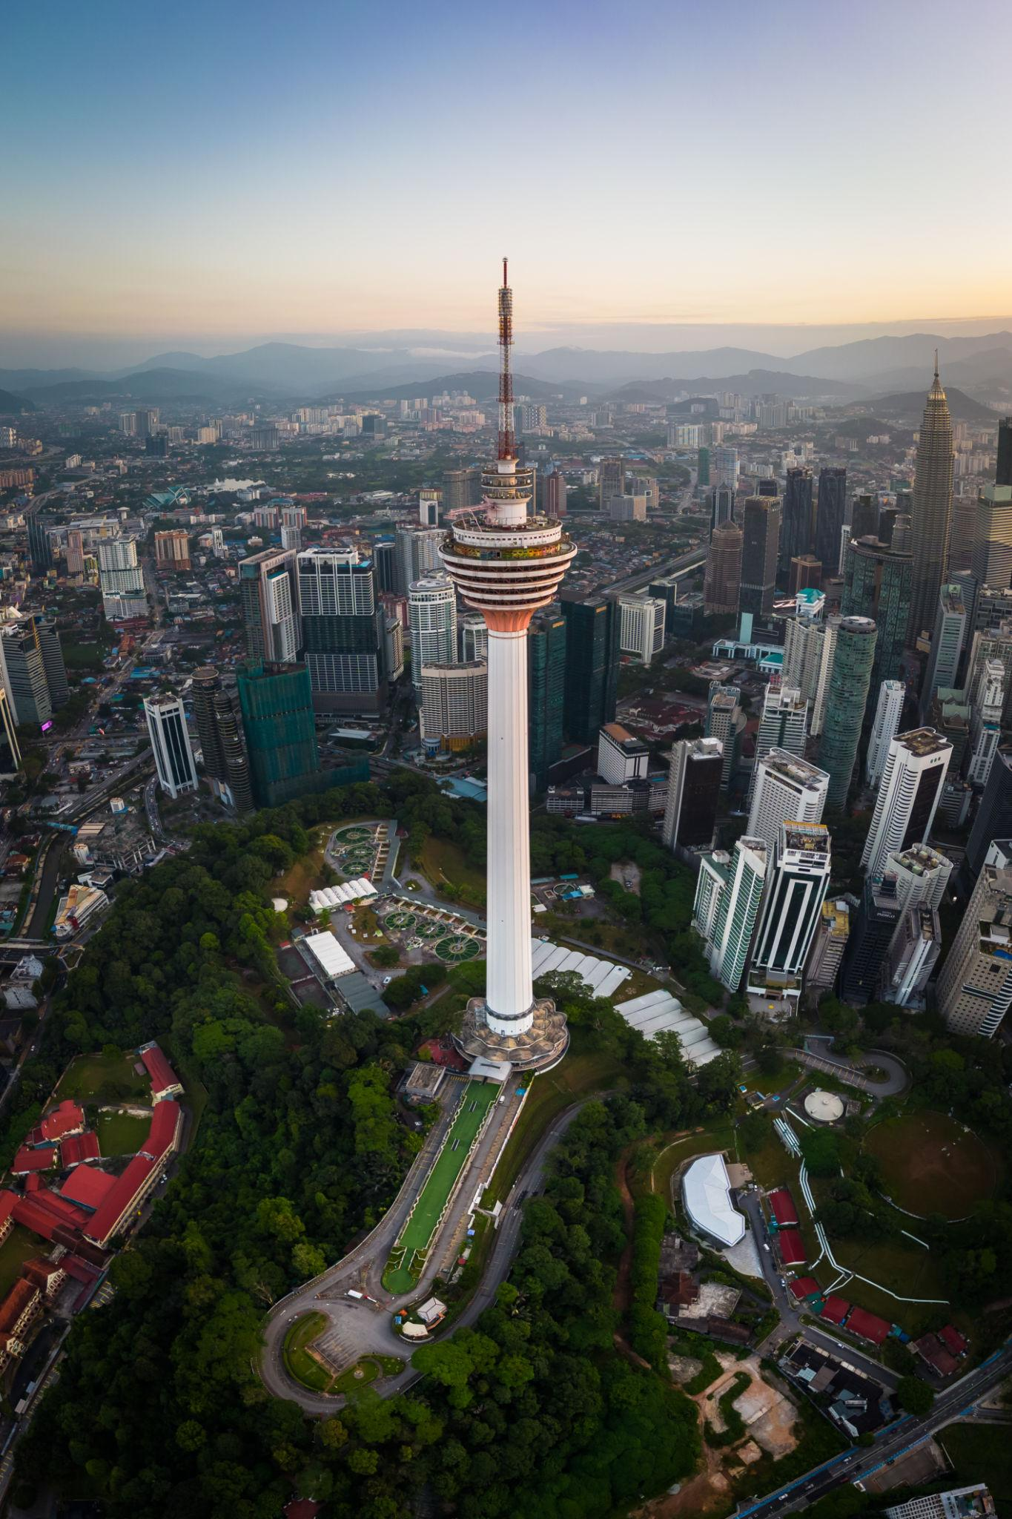
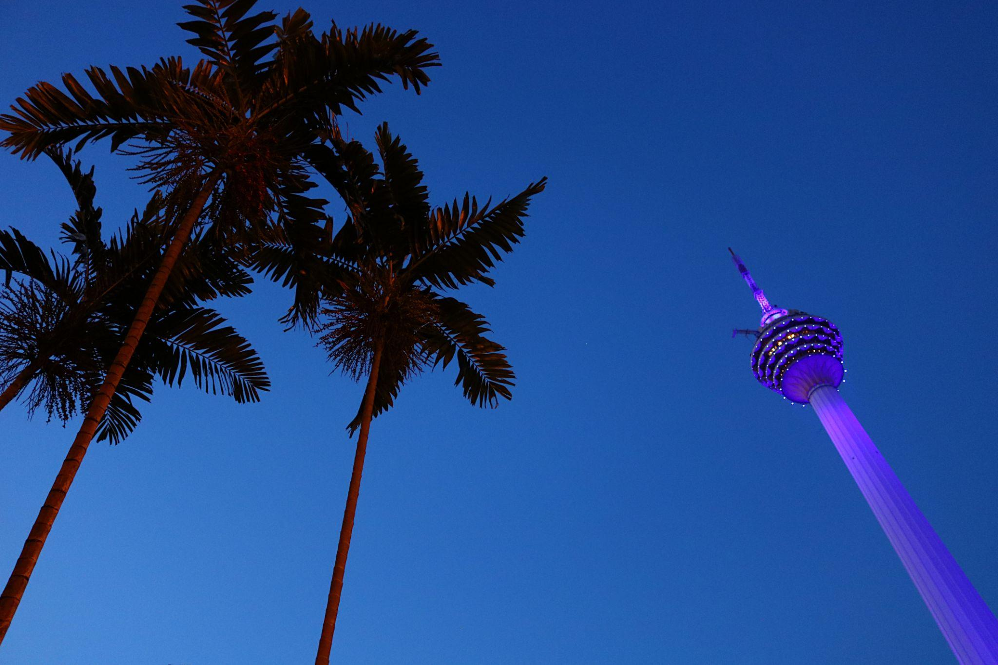
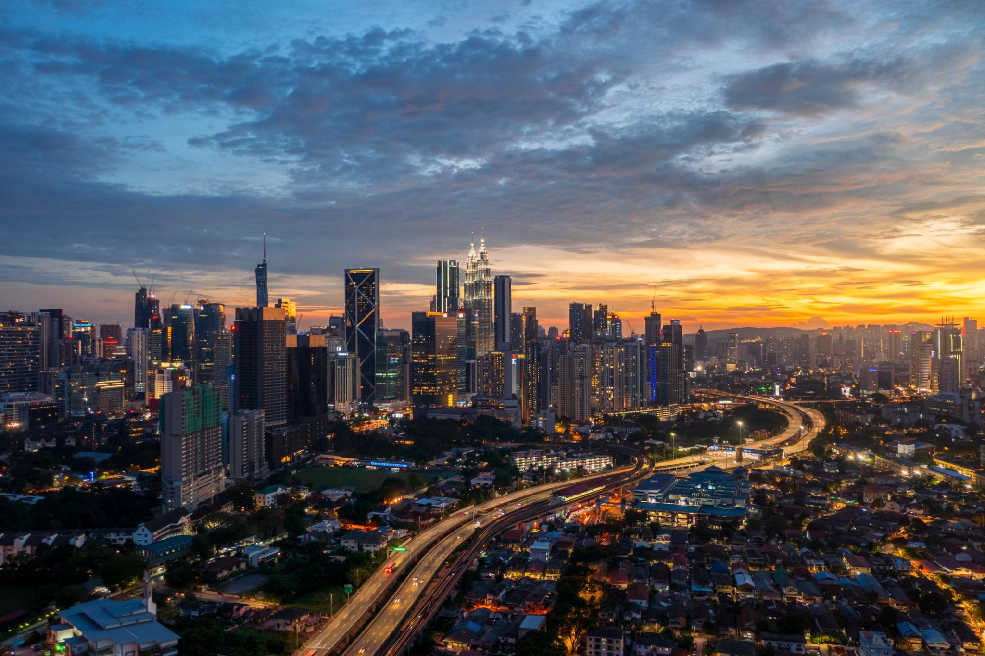

2. Langkawi – Tropical Island Paradise
Langkawi is famous for:
- White sandy beaches
- Luxury resorts
- Island hopping tours
- Water sports
- Stunning sunsets
Must visit:
- Langkawi Sky Bridge
- Cenang Beach
- Mangrove tours

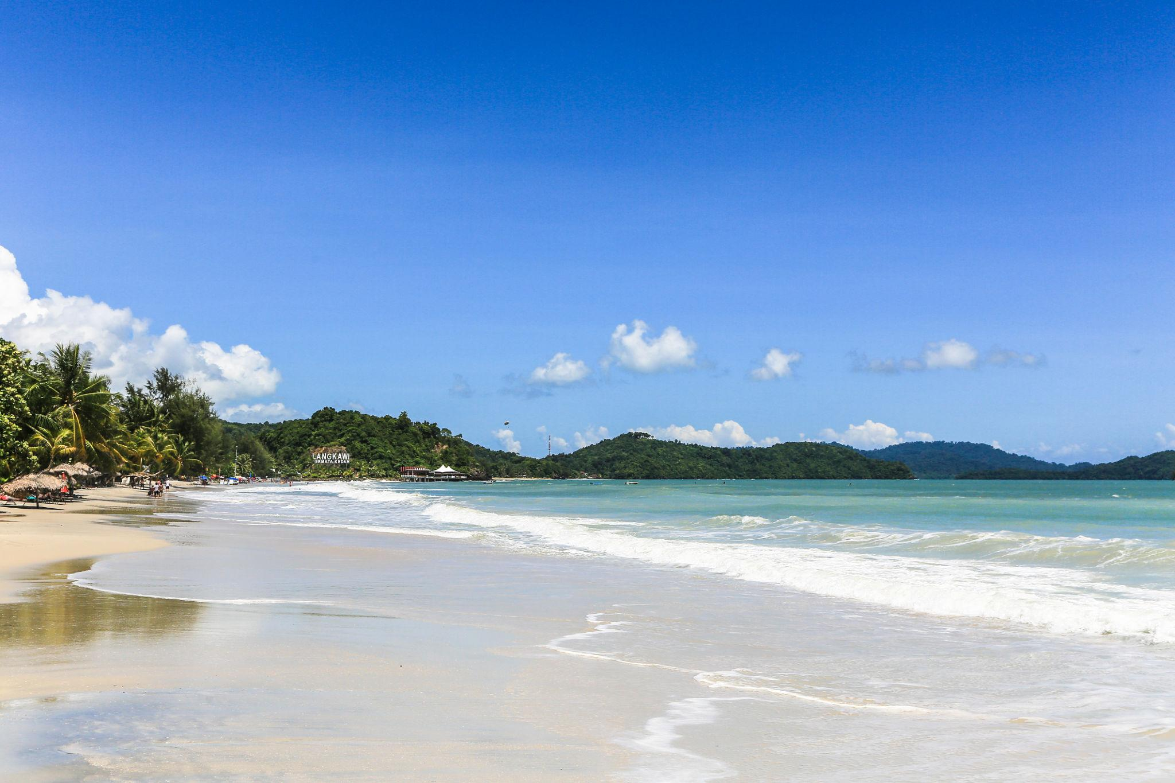
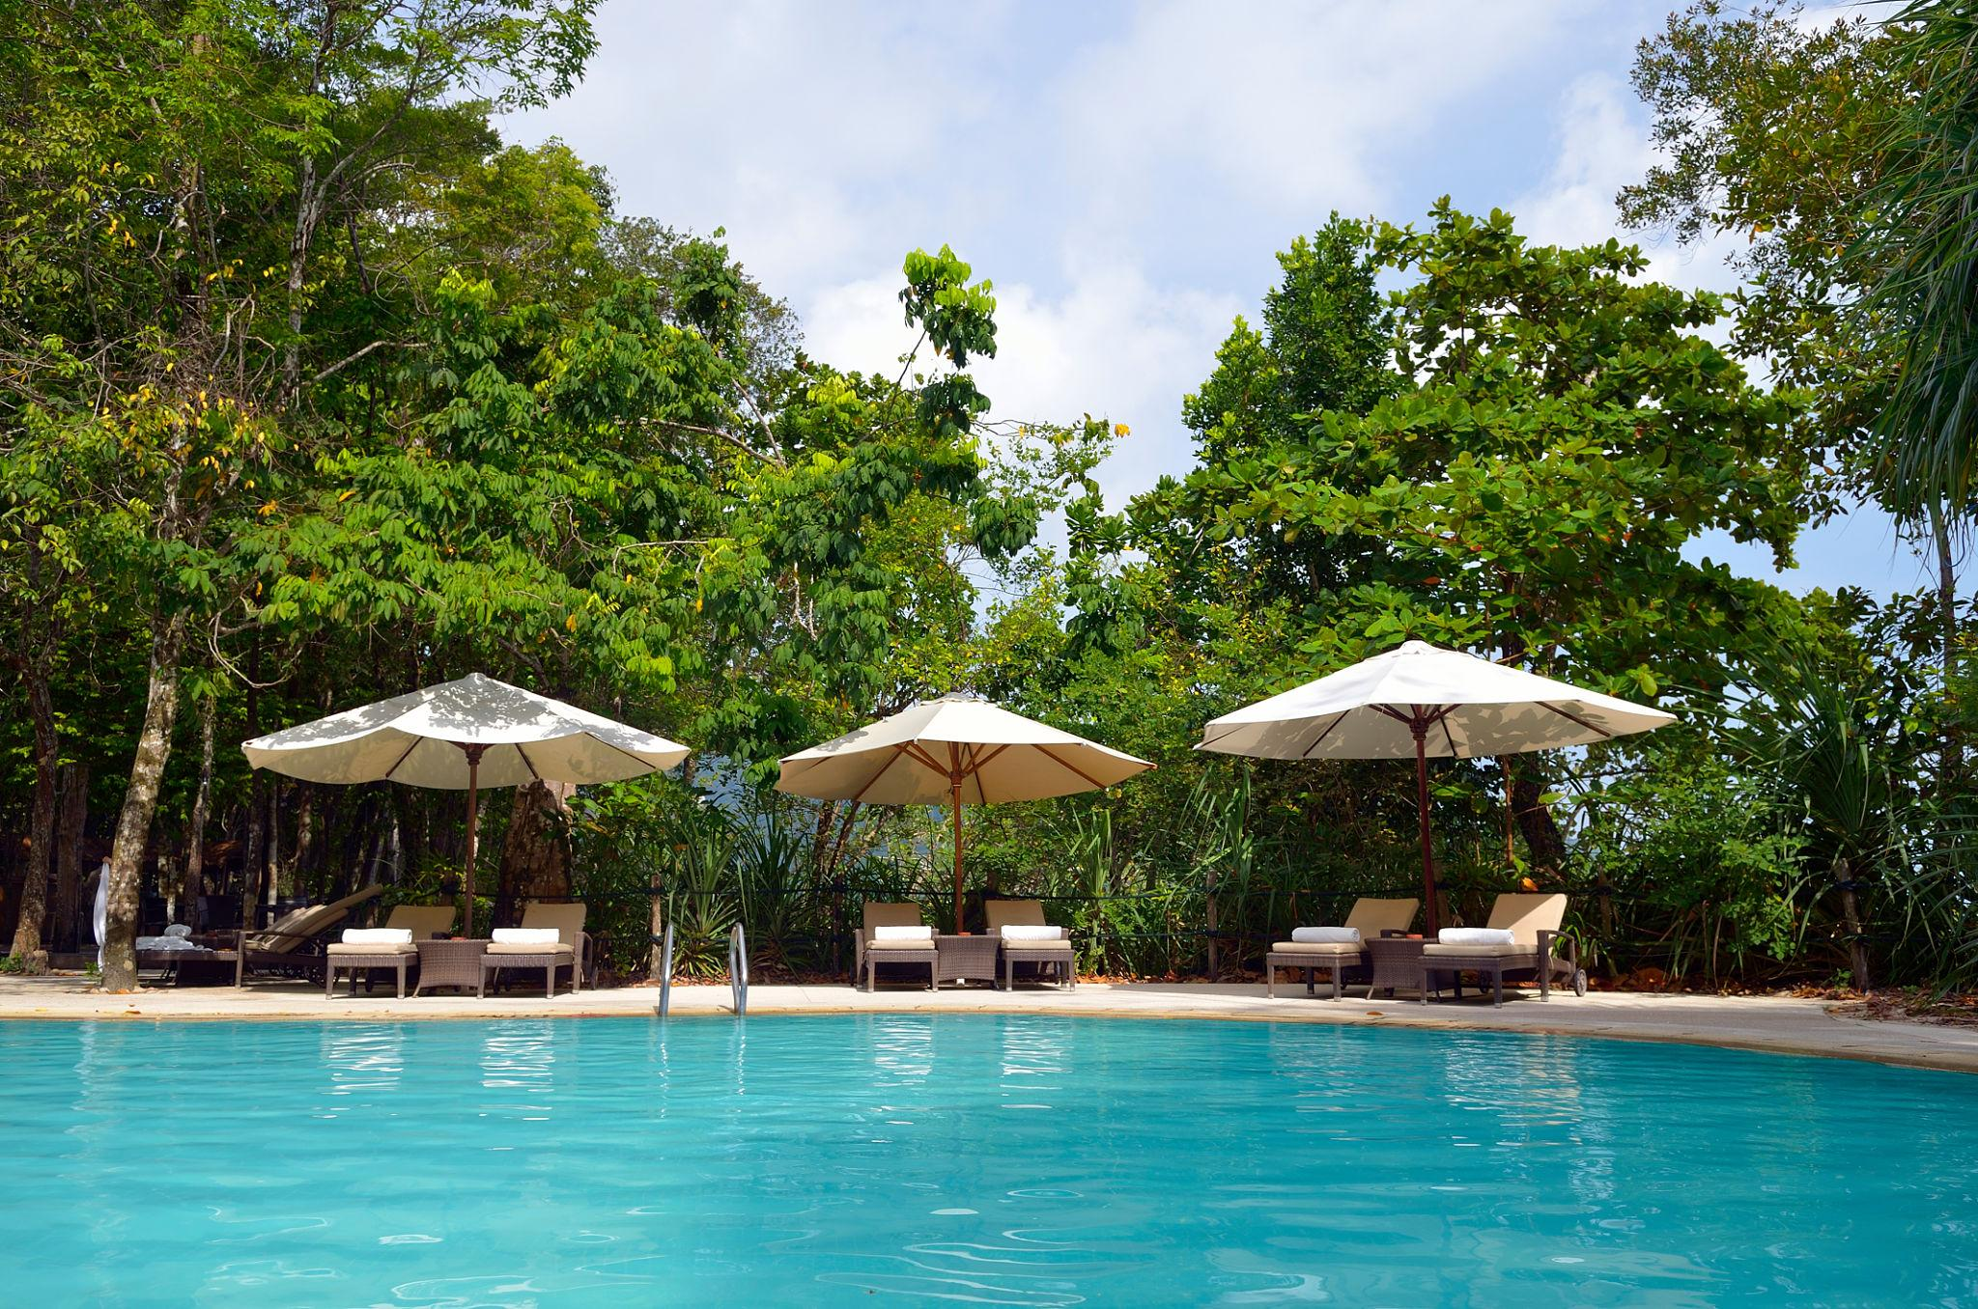

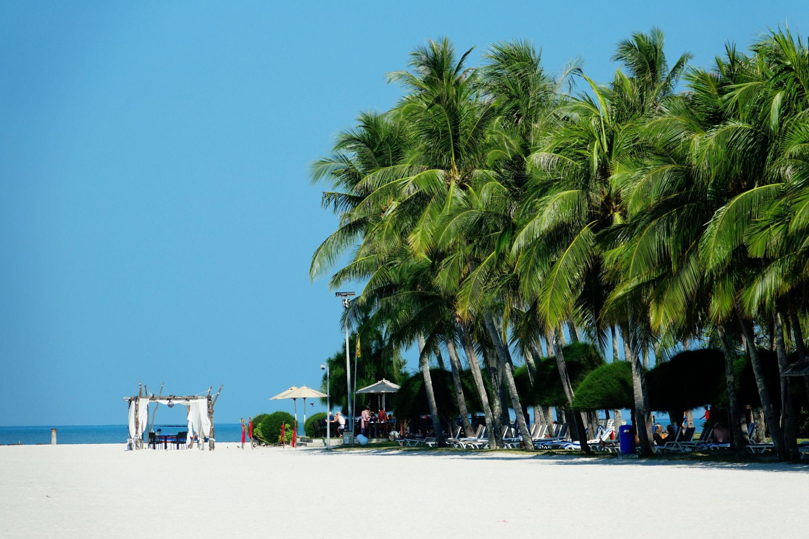


3. Penang – Food & Heritage Destination
Known for:
- Street food
- Colonial architecture
- Art streets
- Cultural heritage
Top attractions:
- George Town
- Penang Hill
- Kek Lok Si Temple

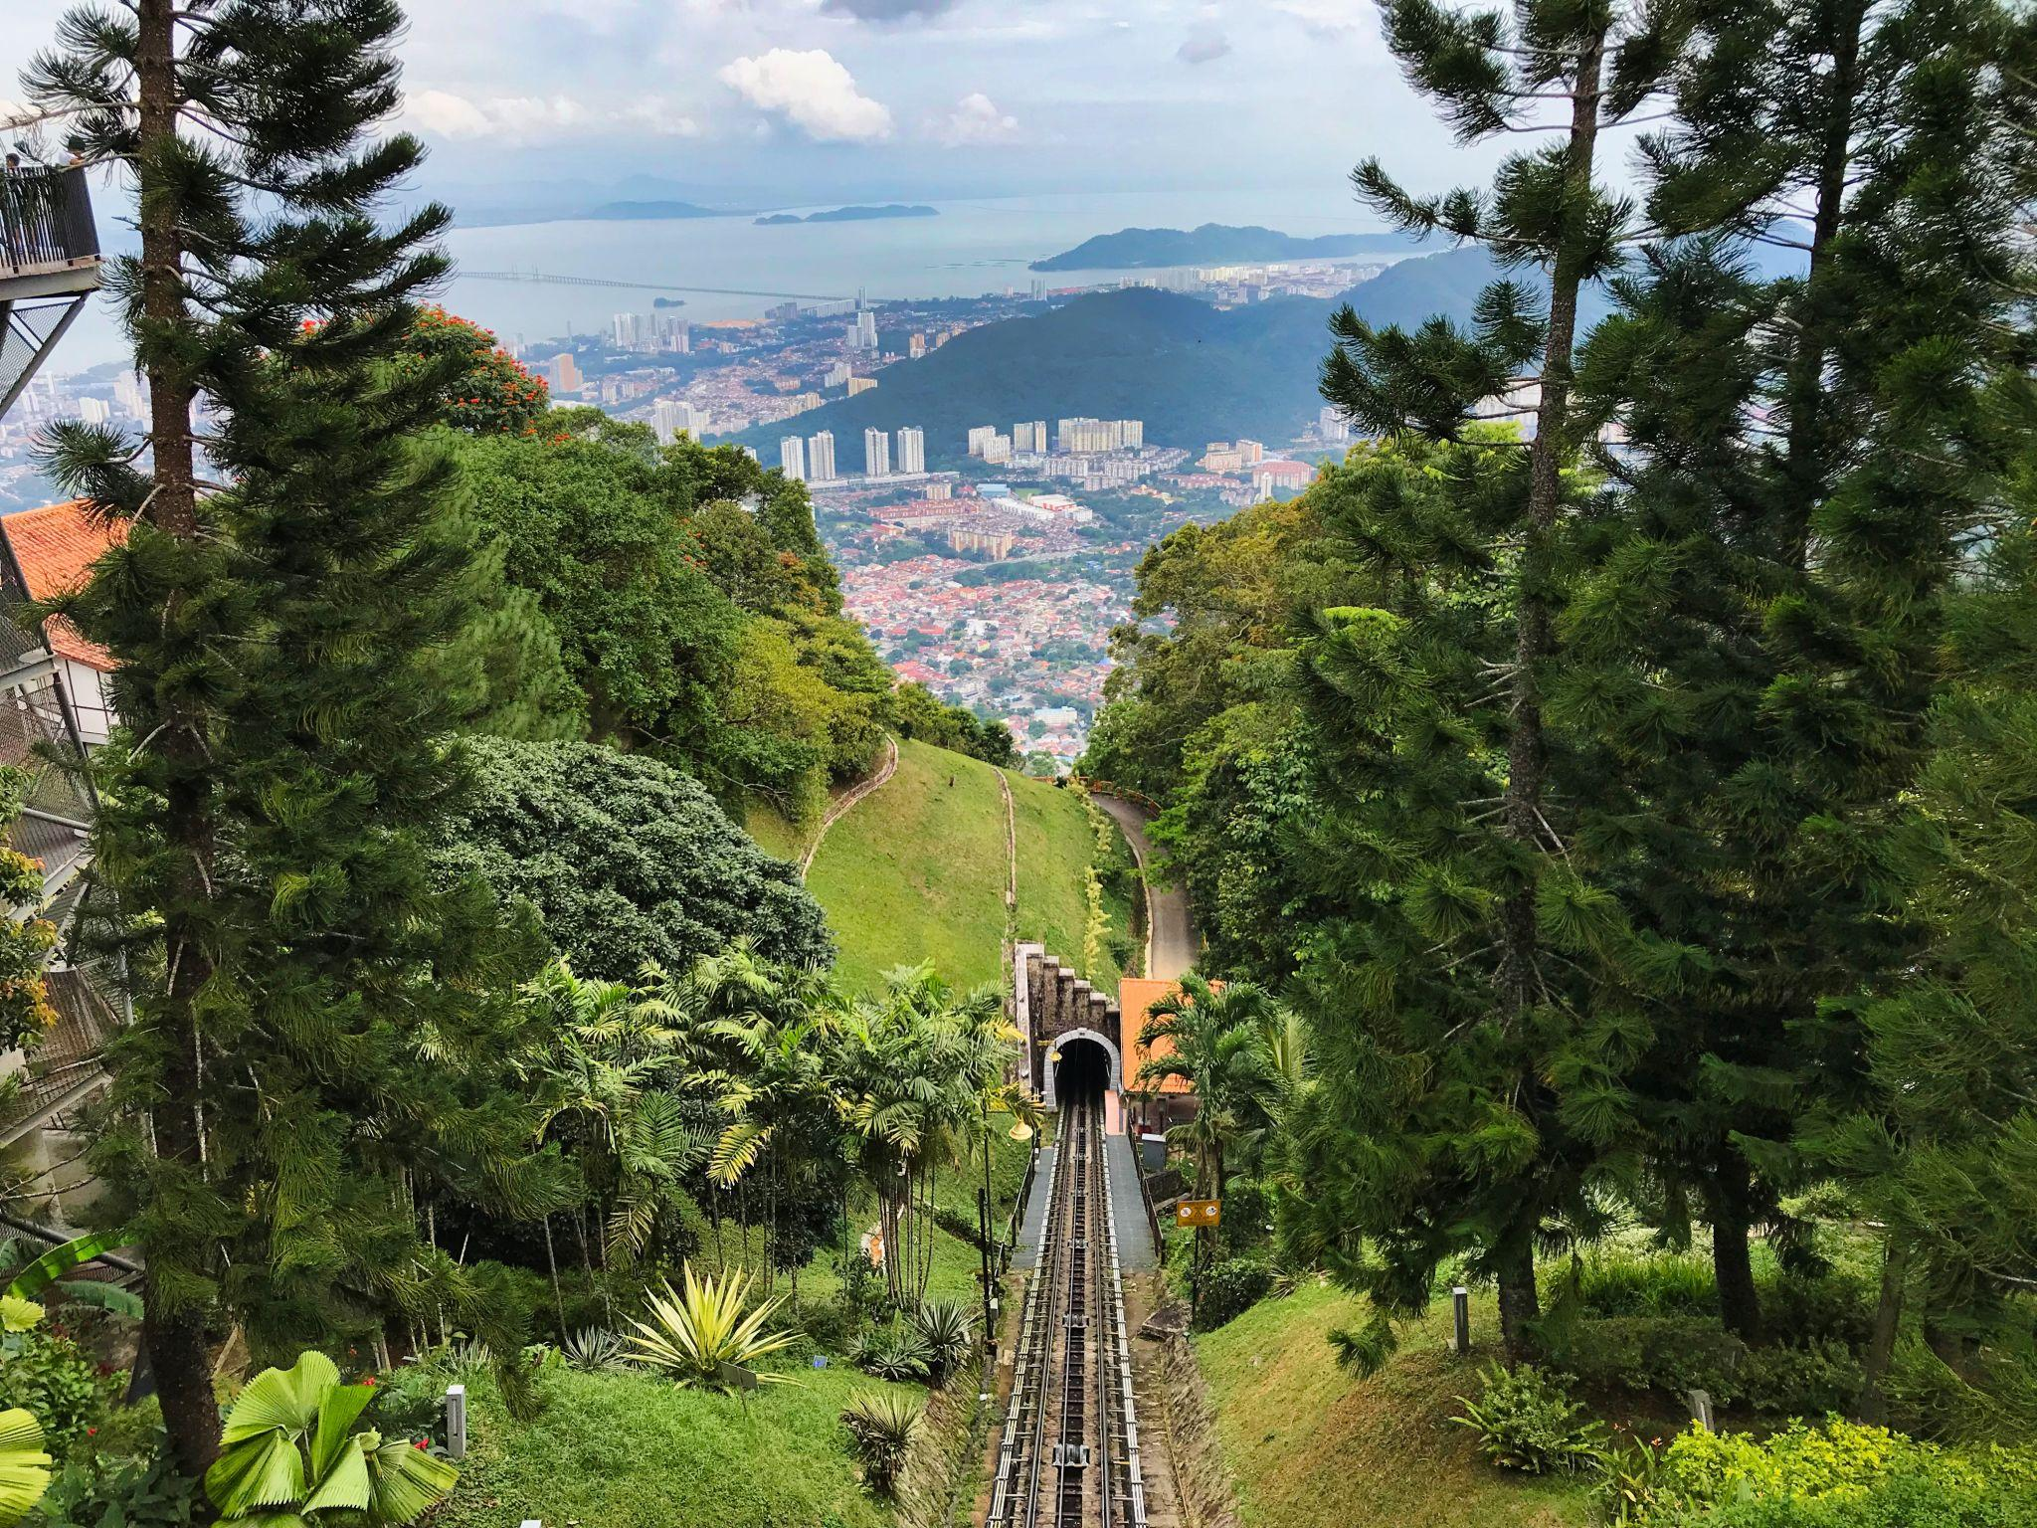
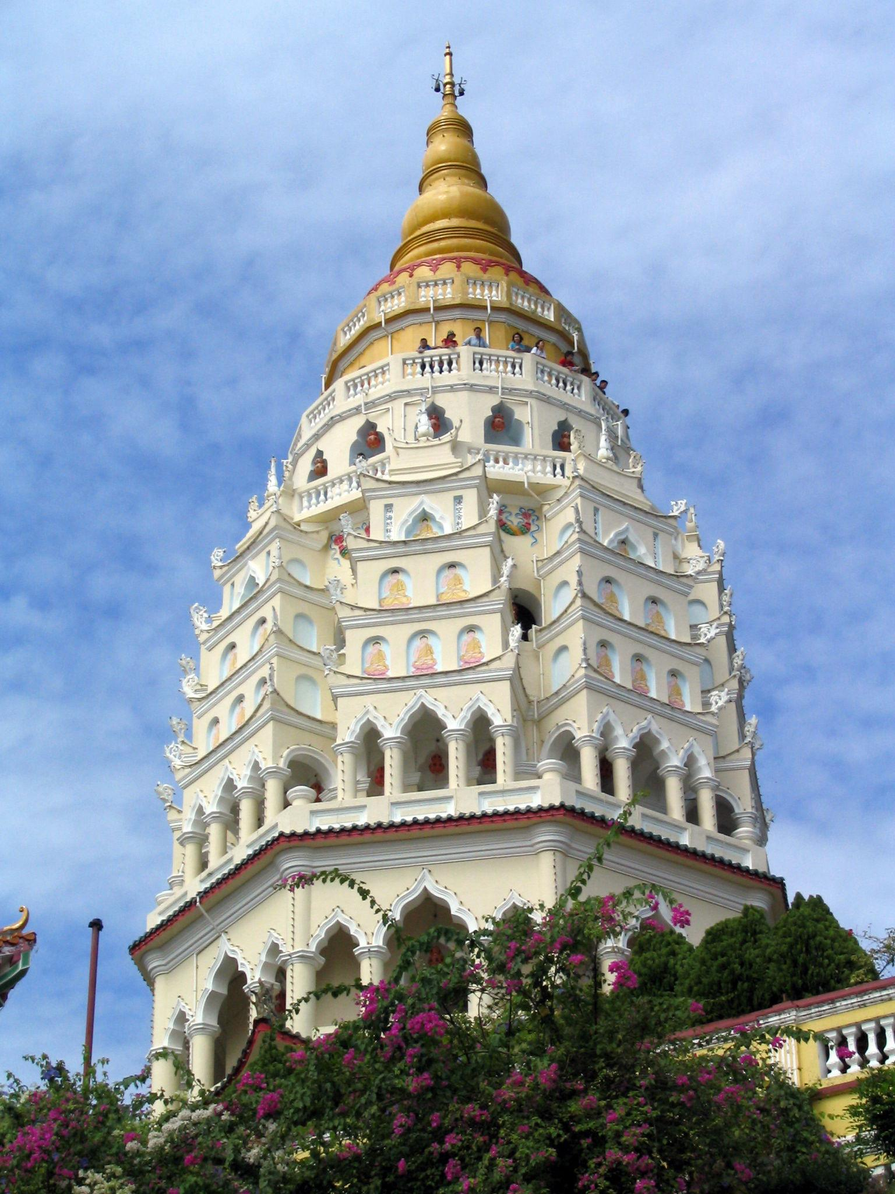

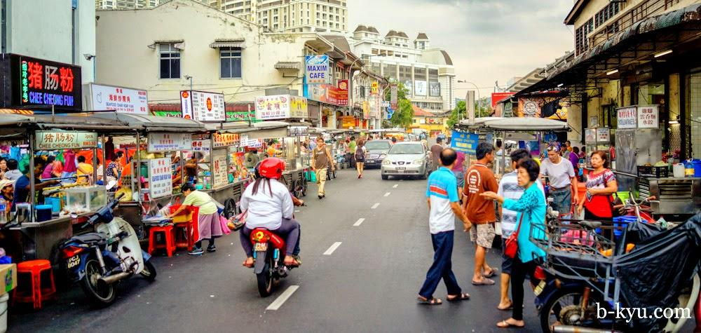
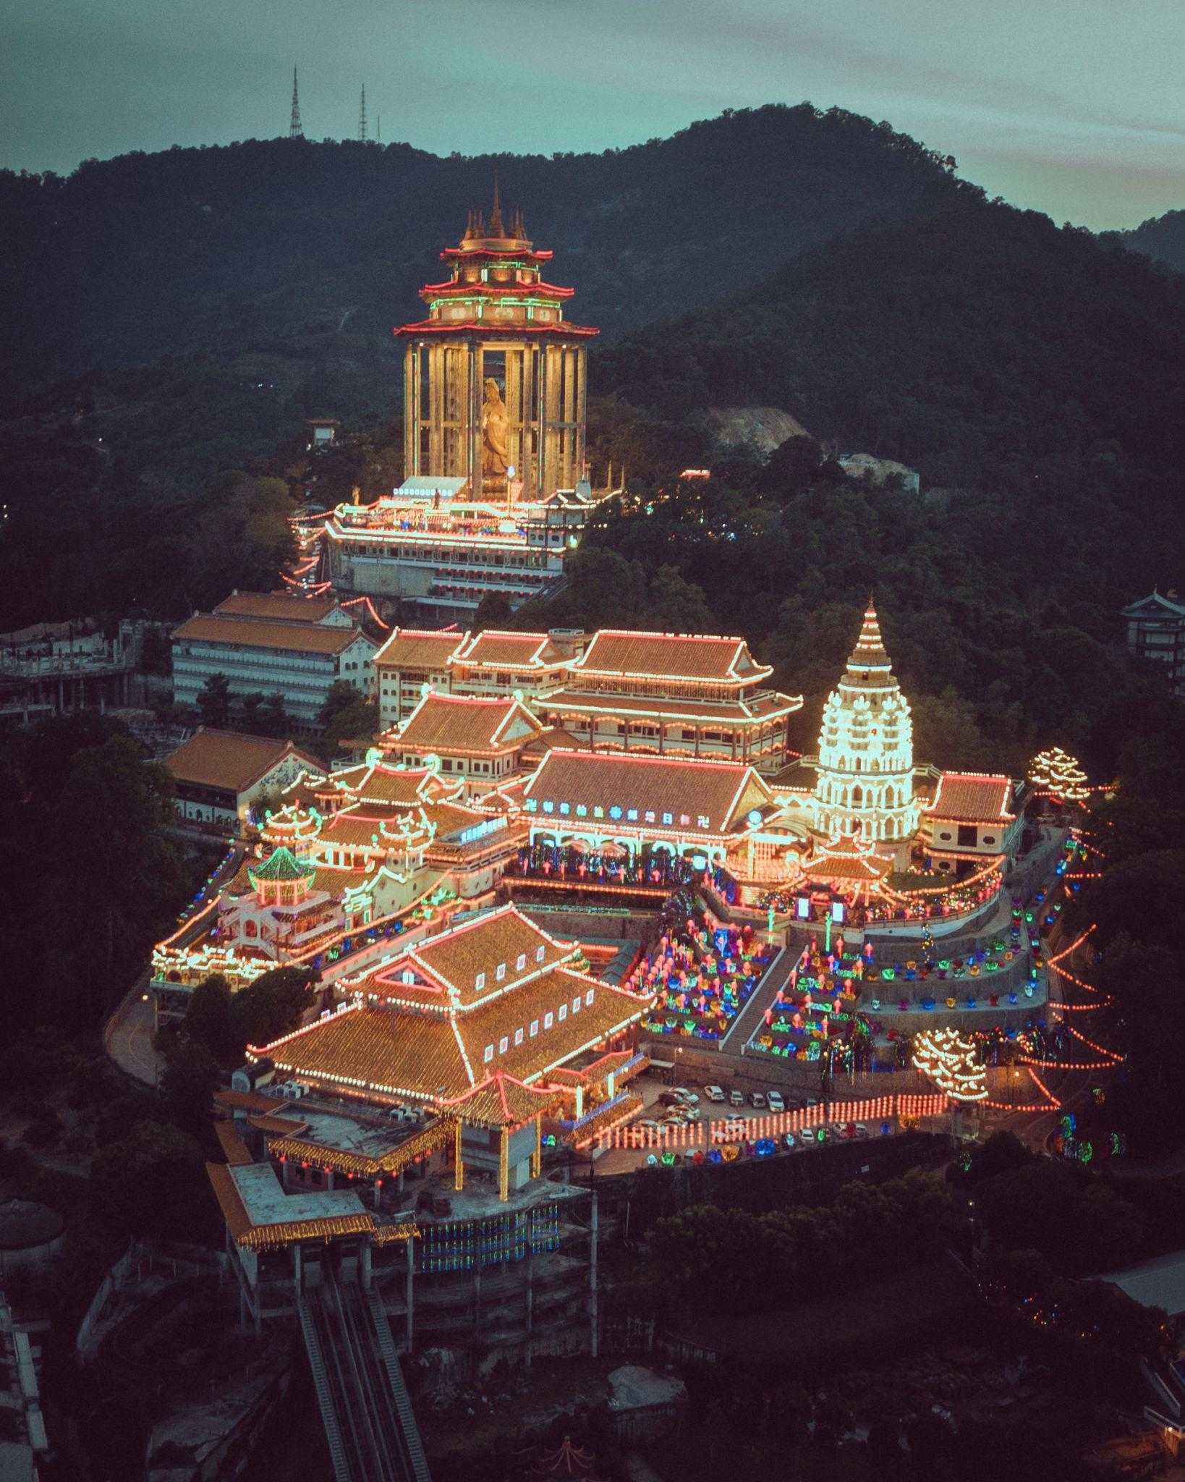

4. Genting Highlands
A cool hill station famous for:
- Resorts & casinos
- Cable car rides
- Theme parks
- Mountain views
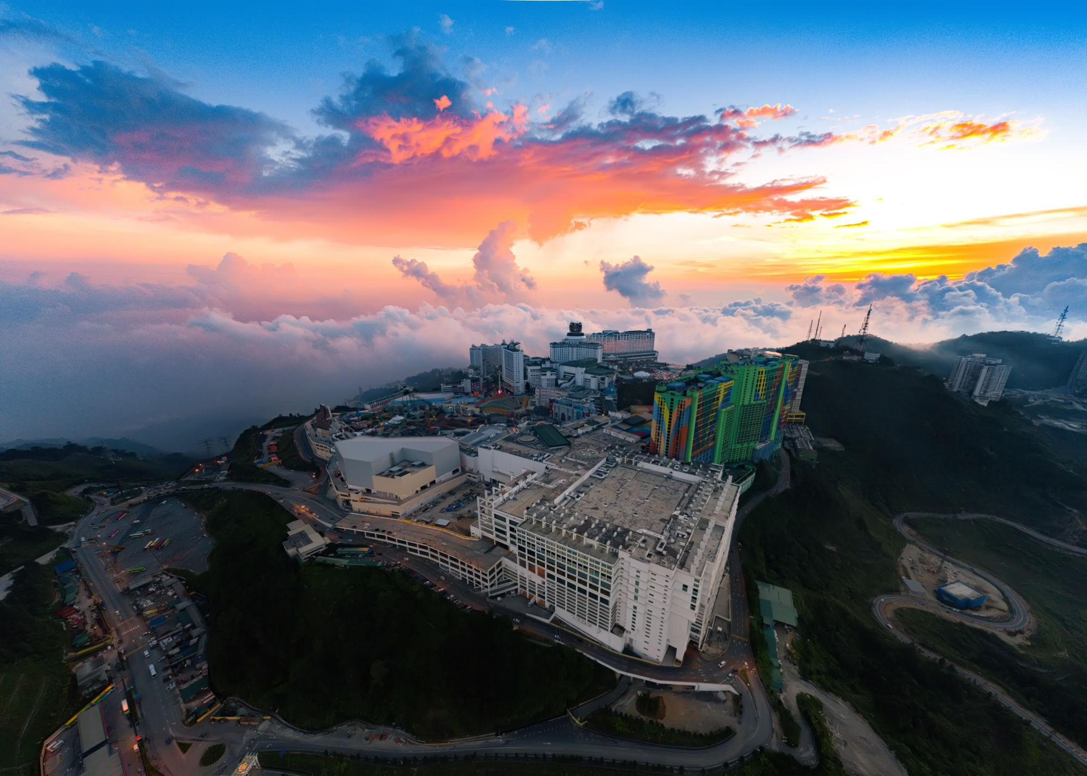

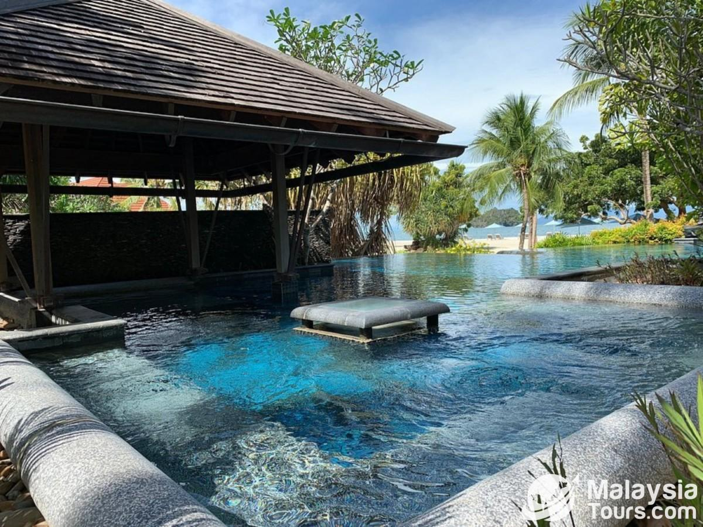


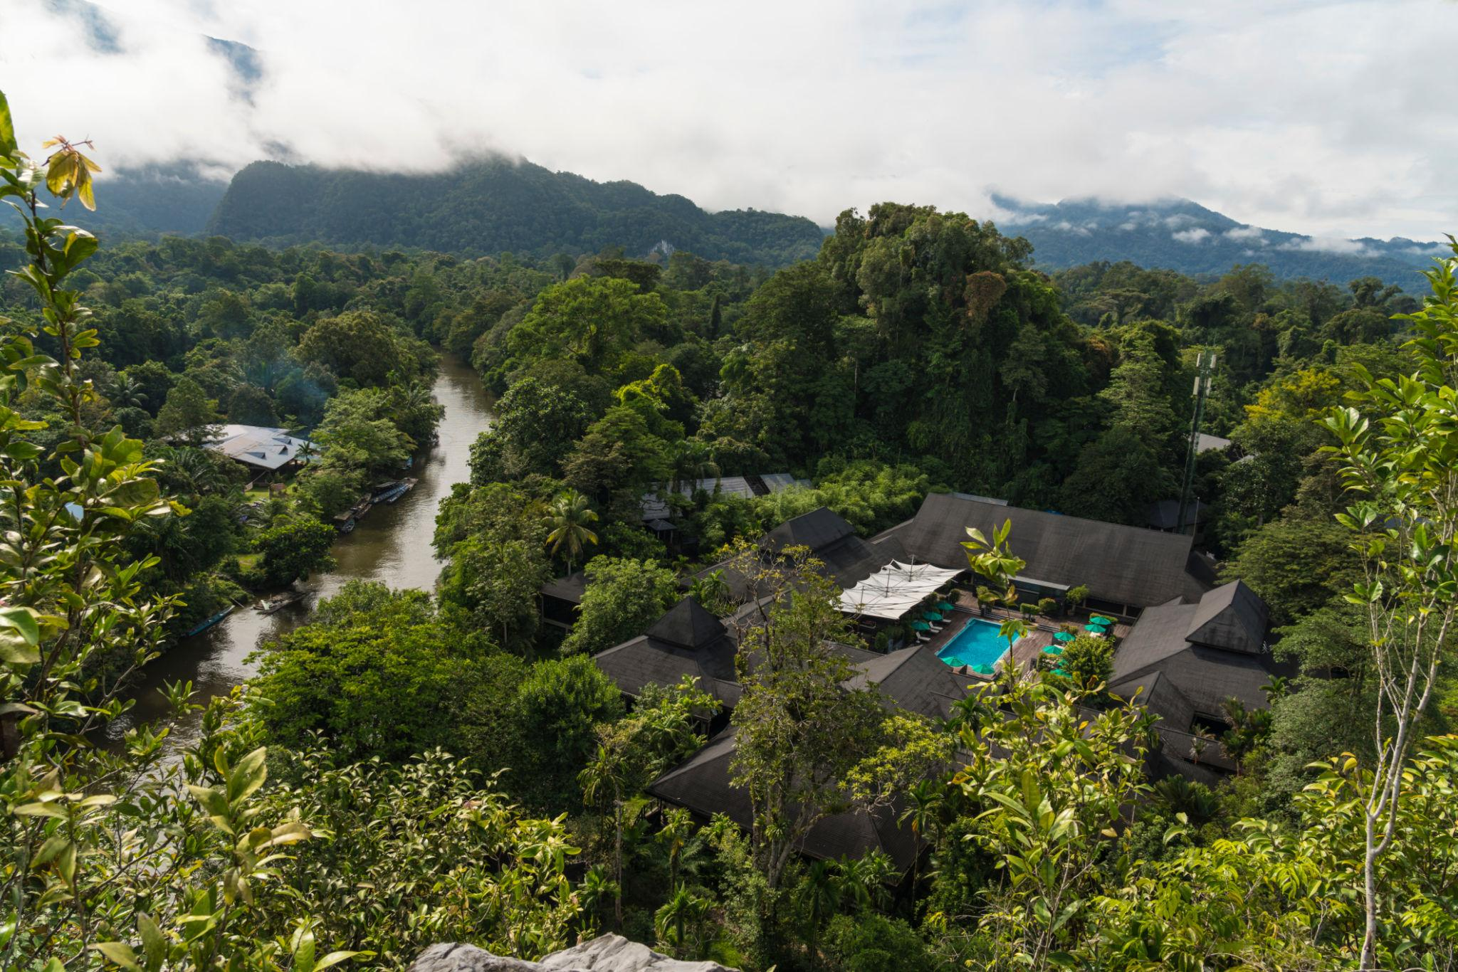
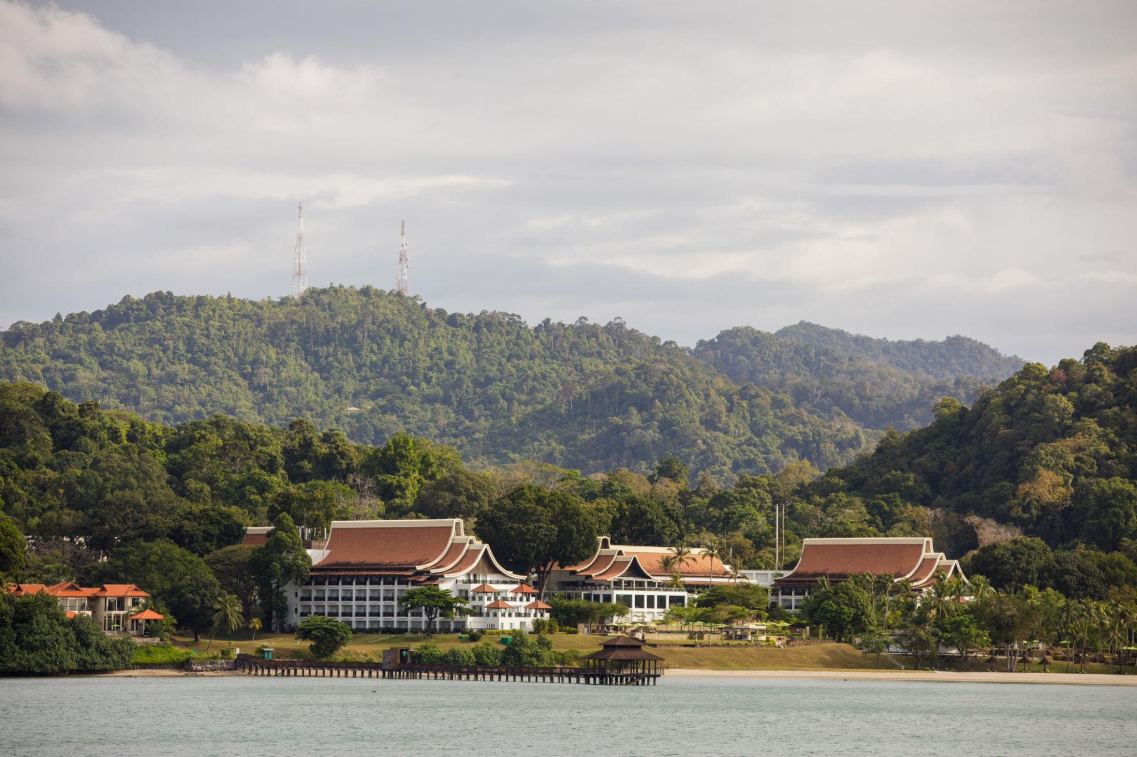

5. Batu Caves
One of Malaysia’s most iconic Hindu pilgrimage sites.
Highlights:
- Giant golden Murugan statue
- Limestone caves
- Colorful staircase
- Hindu temples
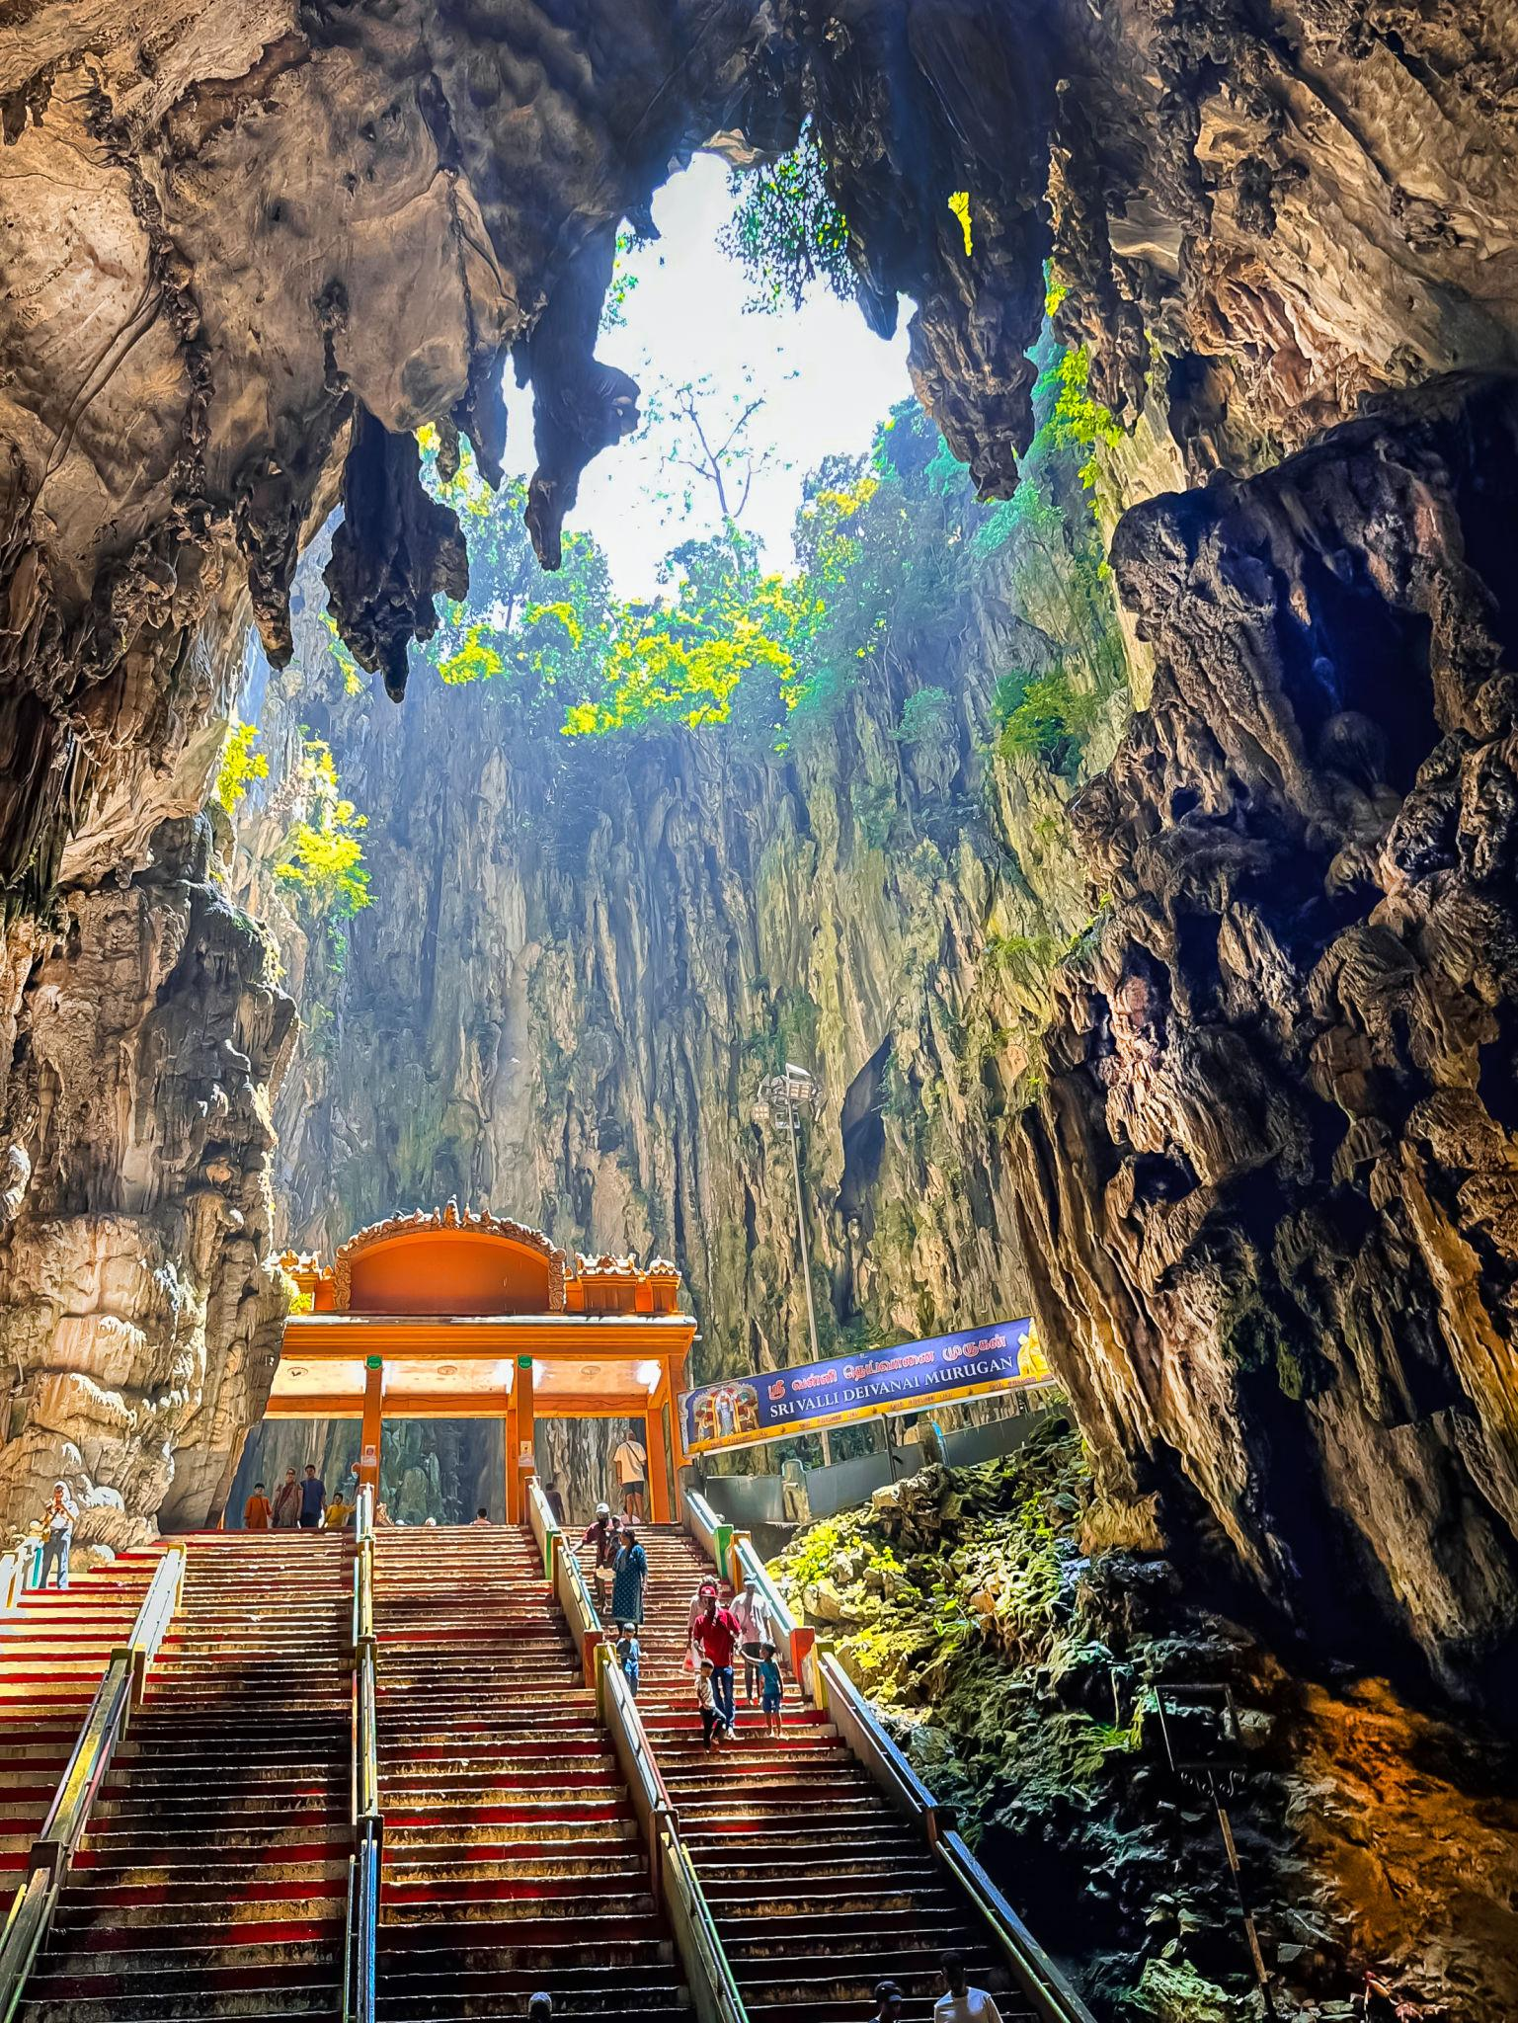
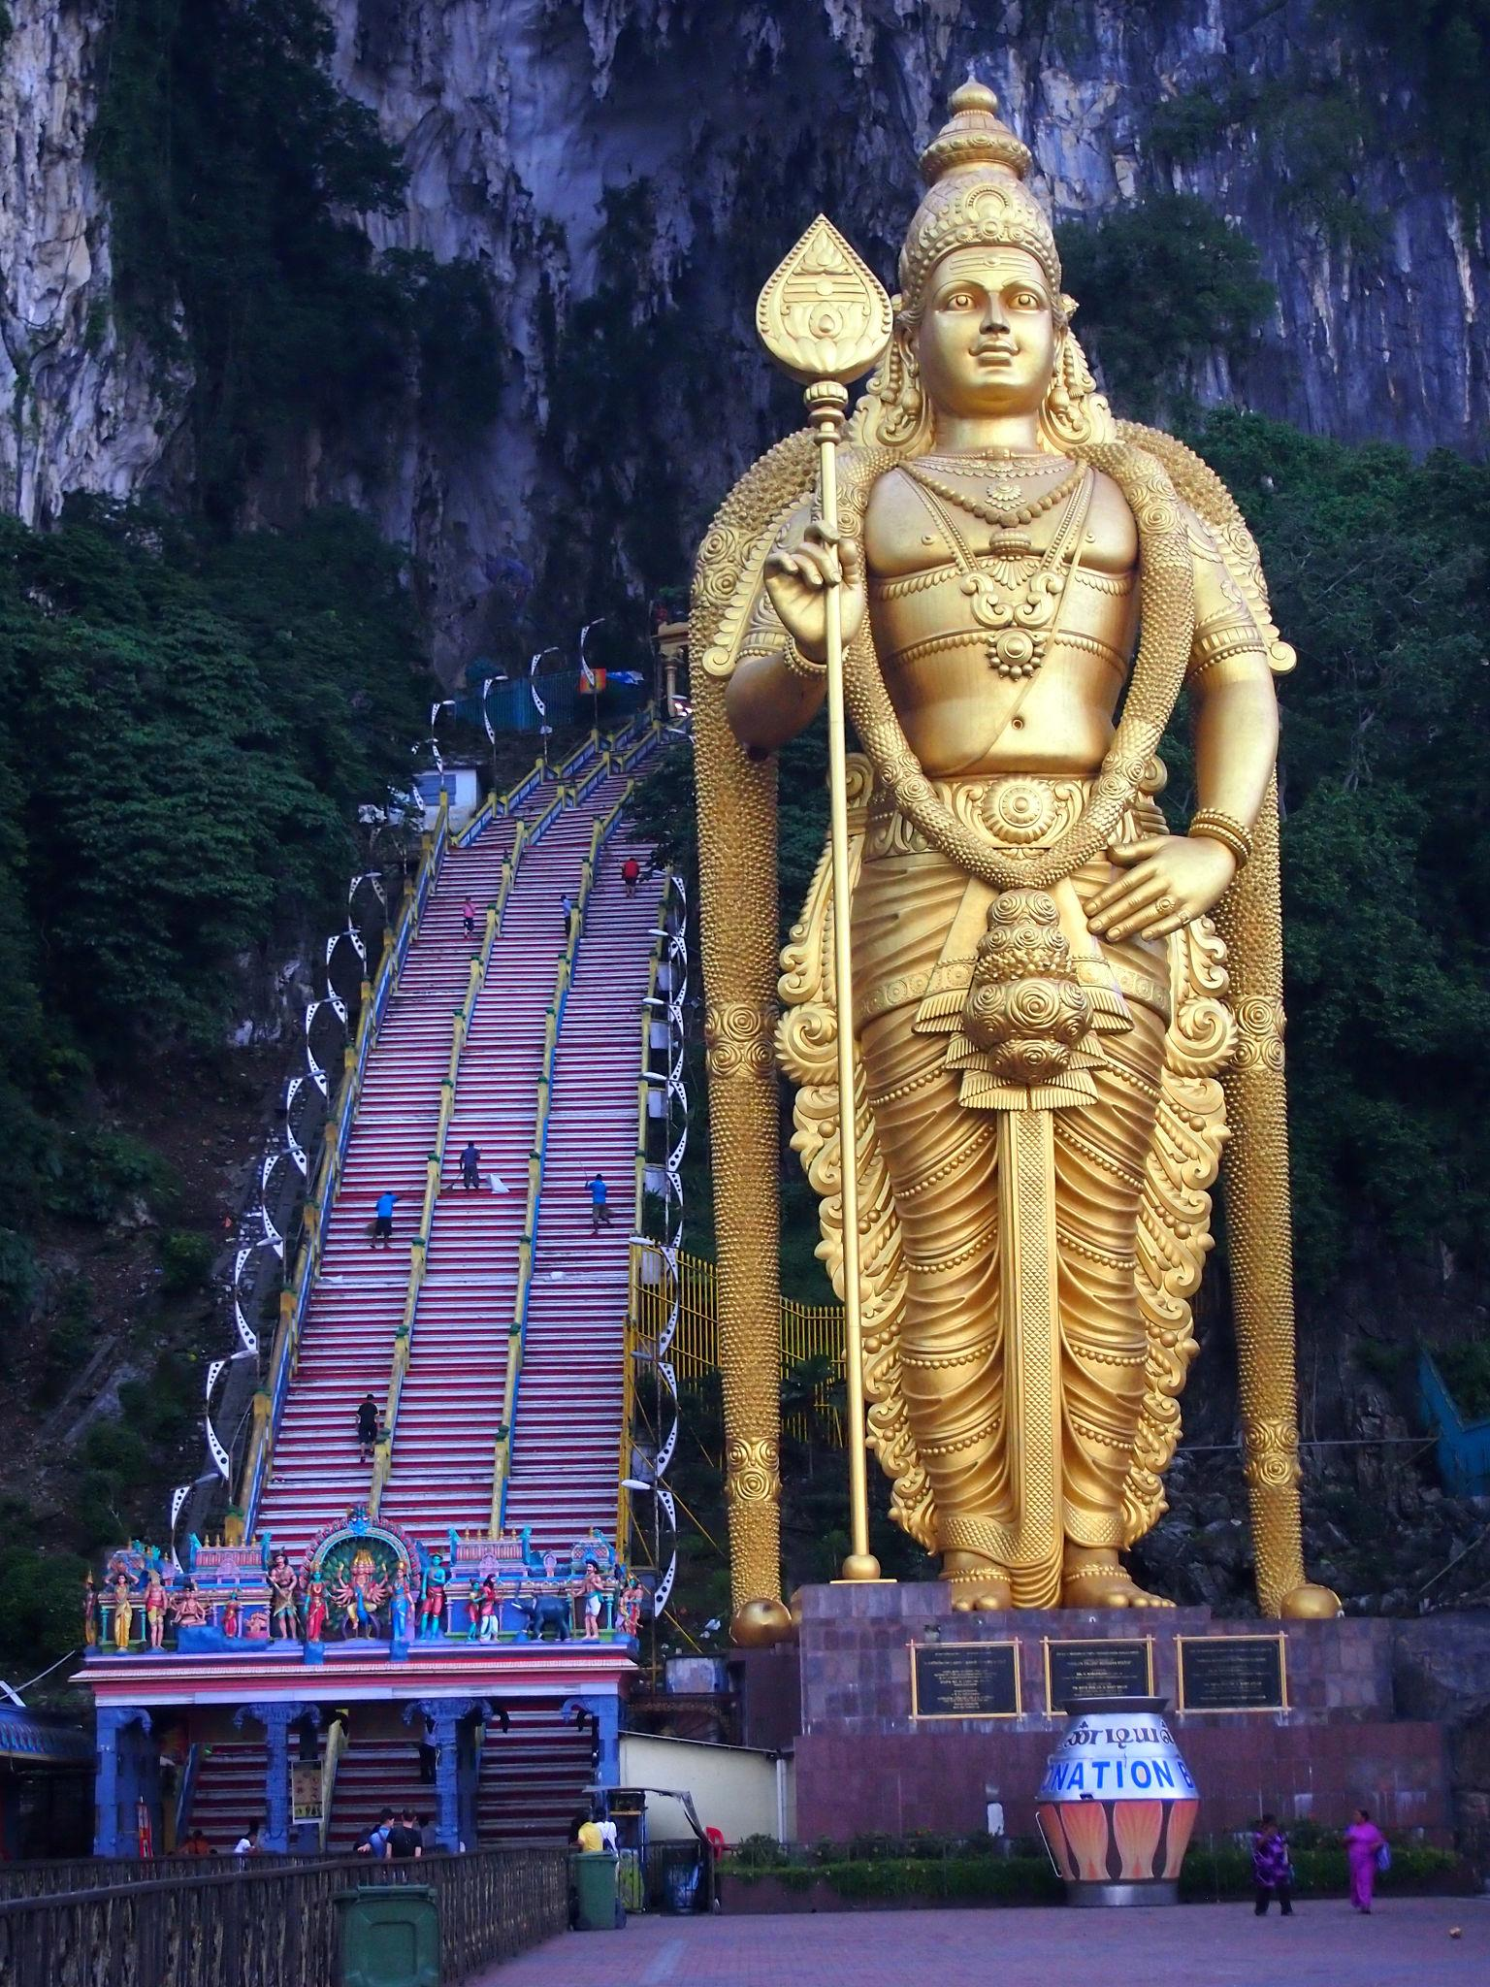
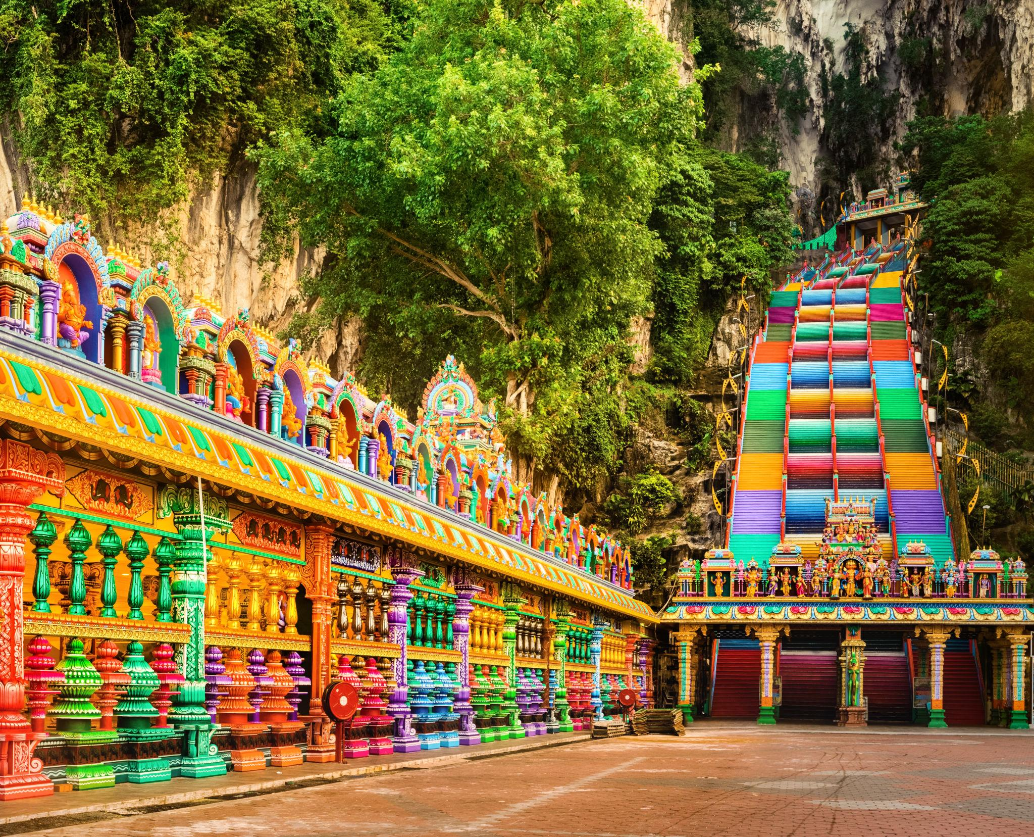
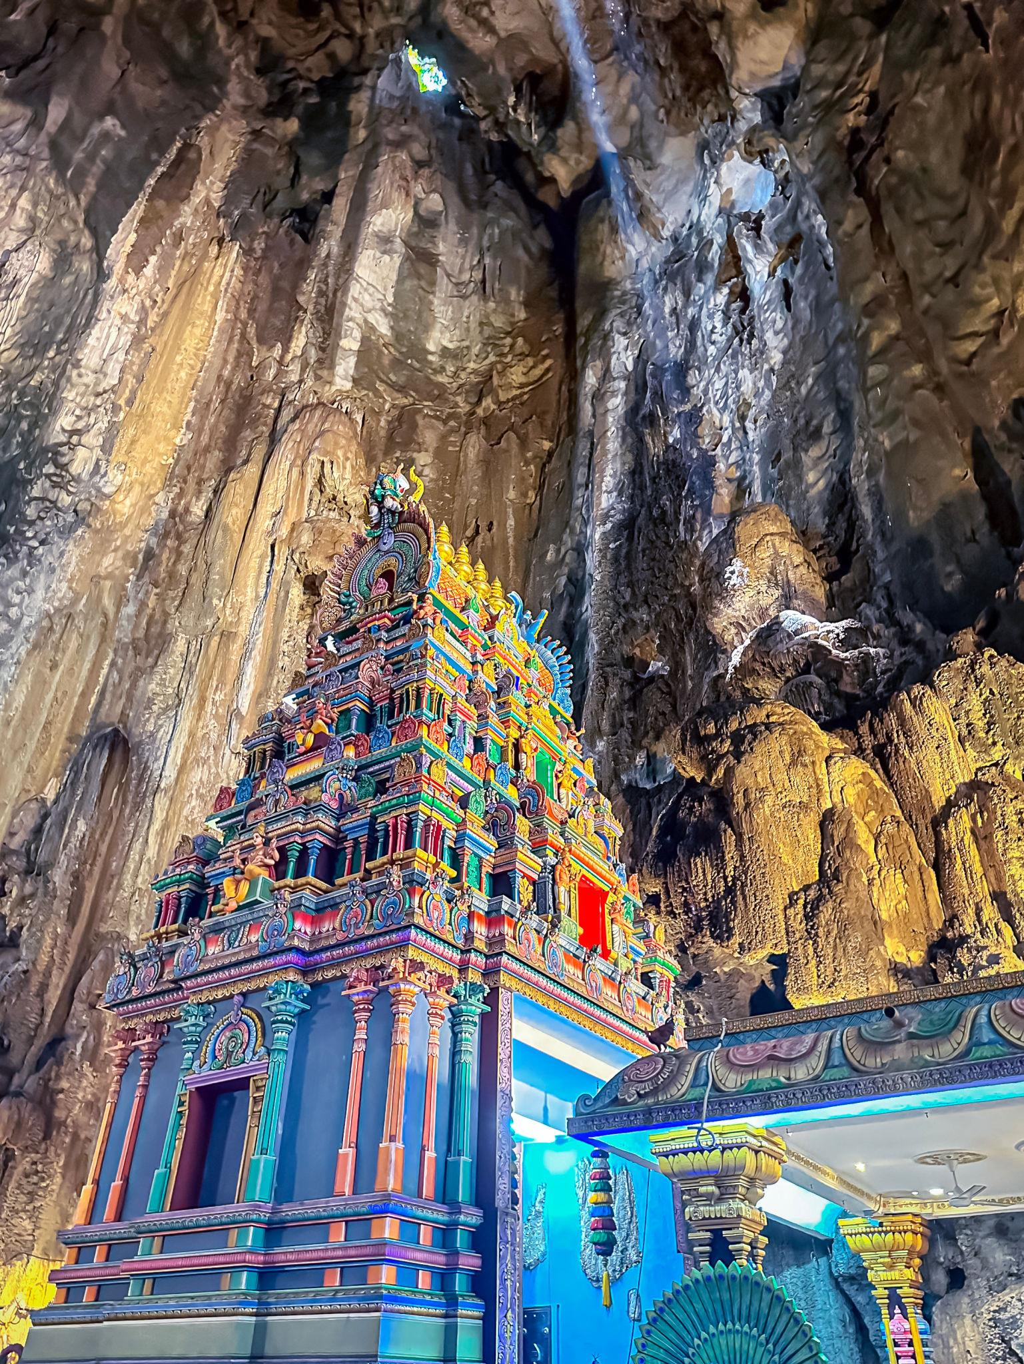
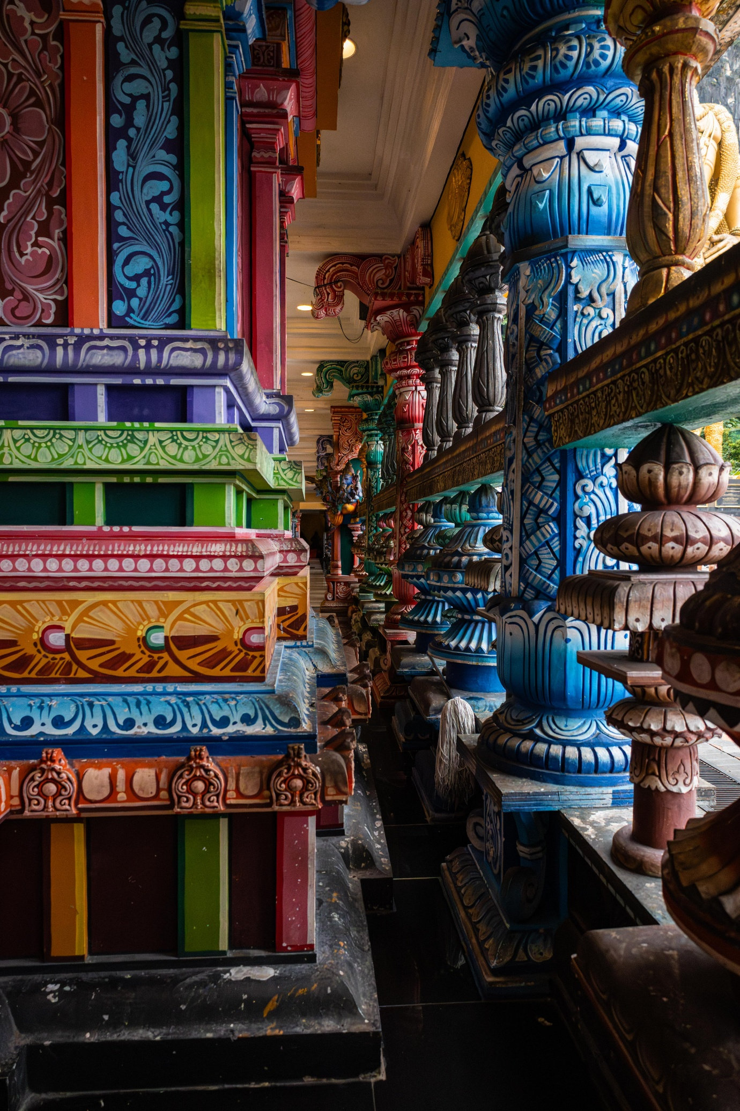
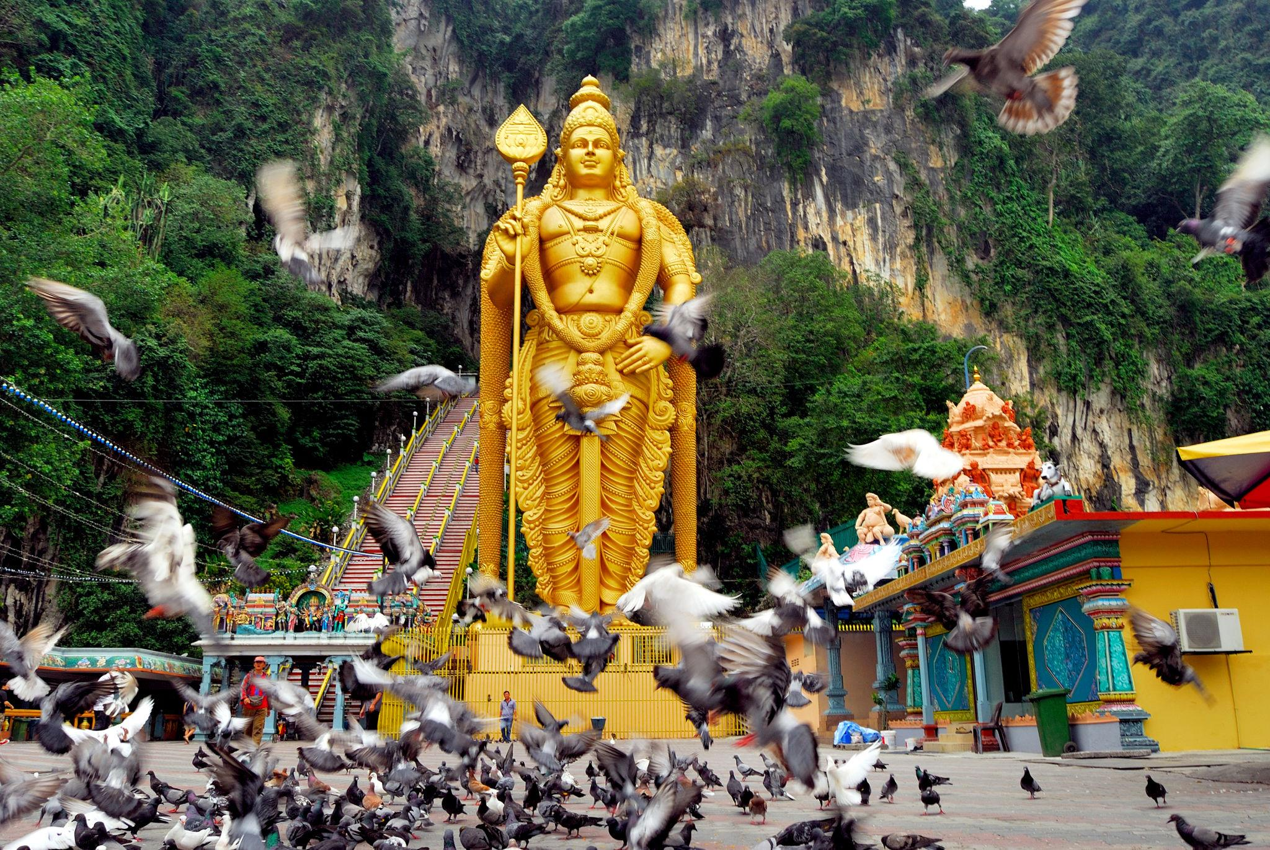
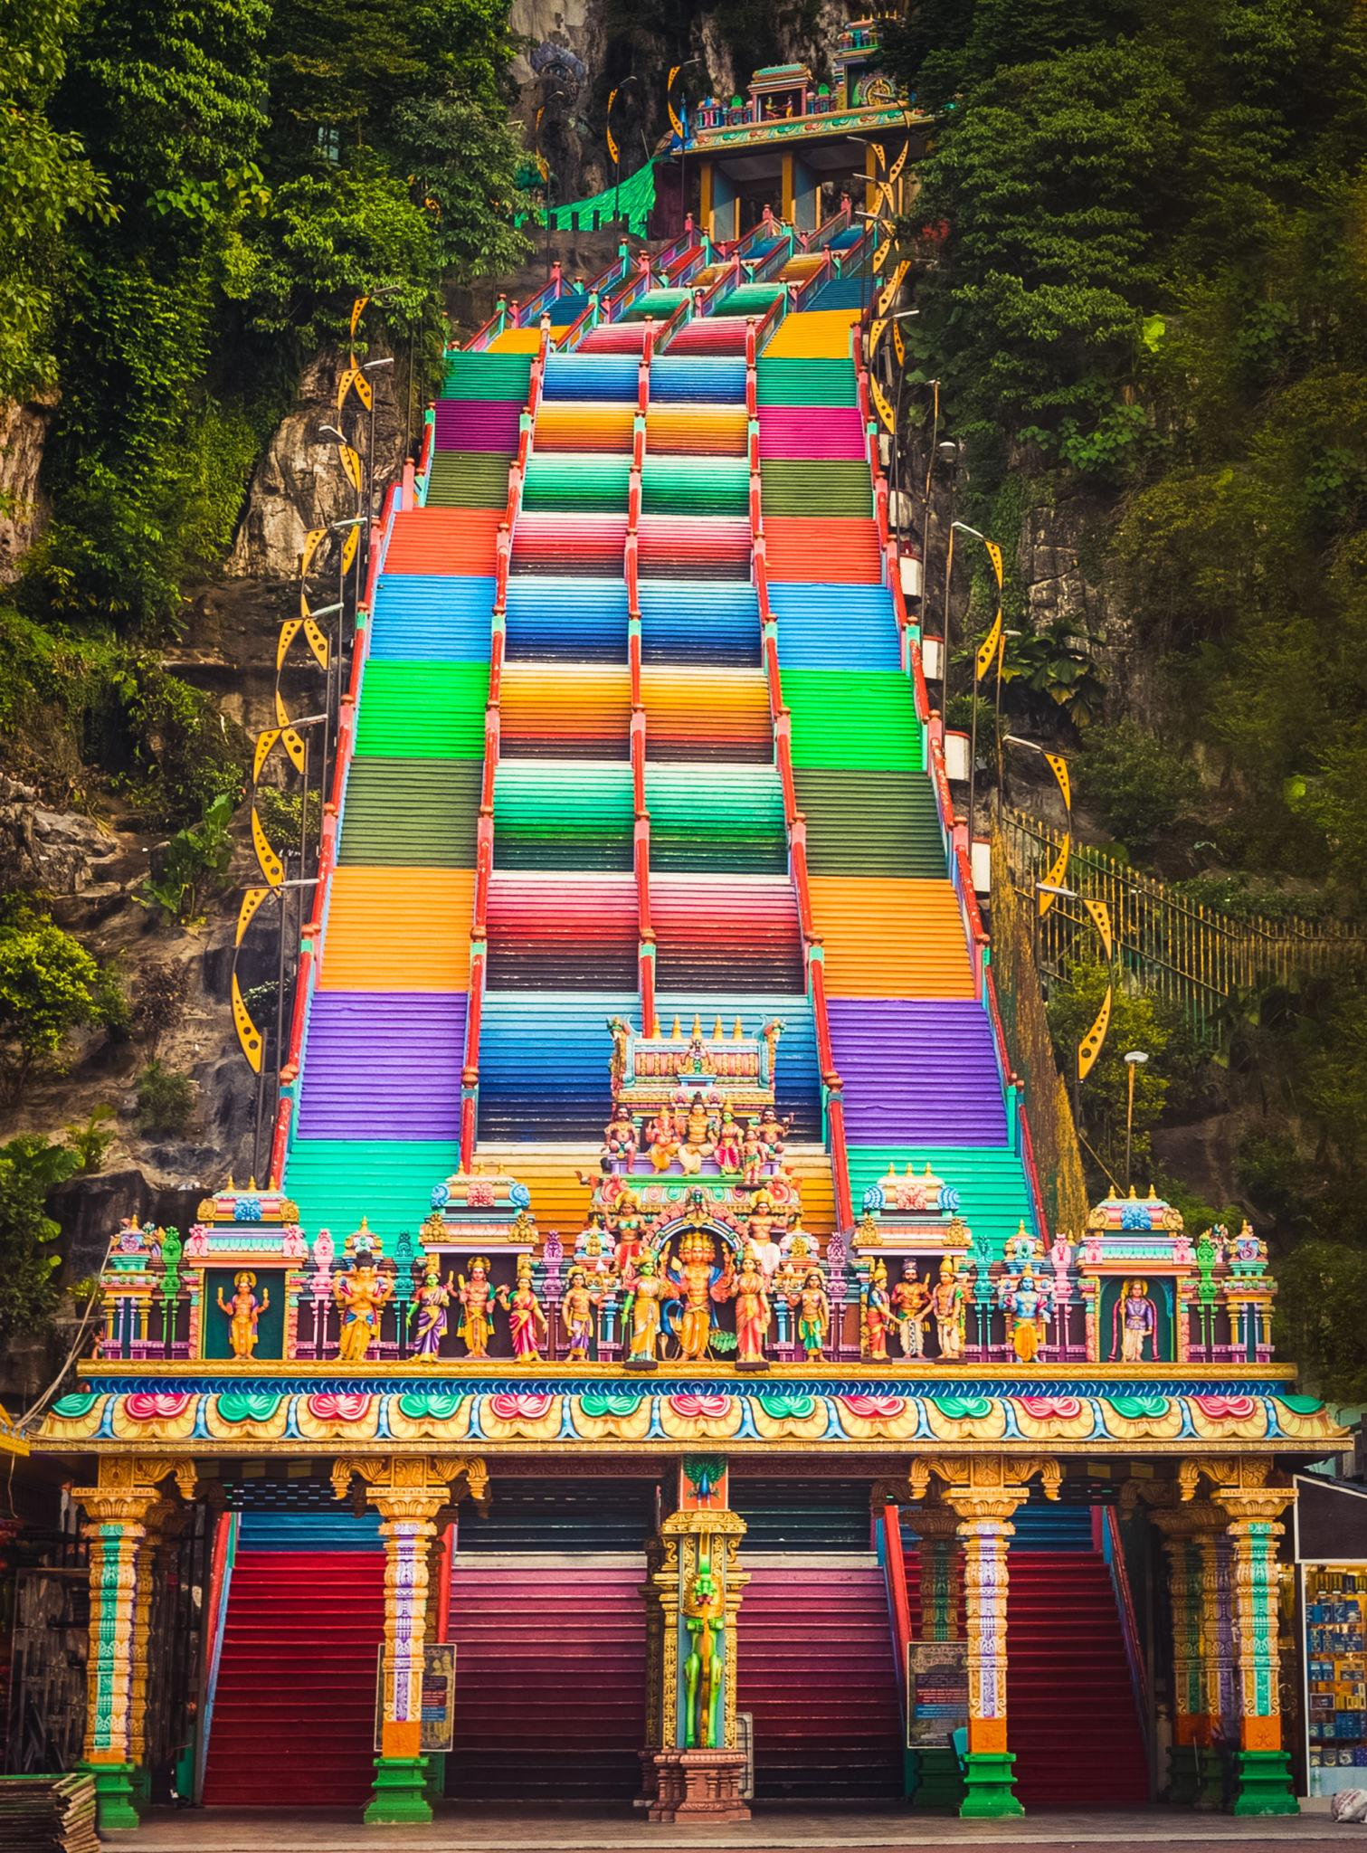

Best Things to Do in Malaysia
- Visit Petronas Twin Towers
- Relax on Langkawi beaches
- Explore Penang street food
- Ride Genting Skyway Cable Car
- Visit Batu Caves
- Go island hopping
- Enjoy rainforest adventures
- Experience Kuala Lumpur nightlife
- Shop at luxury malls & local markets
- Explore Malaysian cultural heritage

Best Time to Visit Malaysia
Region | Best Months
Kuala Lumpur & West Malaysia | December – April
Langkawi | November – March
East Coast Islands | March – October
Malaysia has a tropical climate and can be visited year-round.

Malaysia Visa for Indians 🇮🇳
Indian travelers generally require:
- Passport valid for 6 months
- Malaysia tourist visa or eVisa
- Return flight tickets
- Hotel bookings
- Sufficient funds
Malaysia often offers simplified eVisa/eNTRI facilities for Indian tourists.

Famous Malaysian Foods to Try 🍜
- Nasi Lemak
- Satay
- Laksa
- Roti Canai
- Char Kway Teow
- Teh Tarik
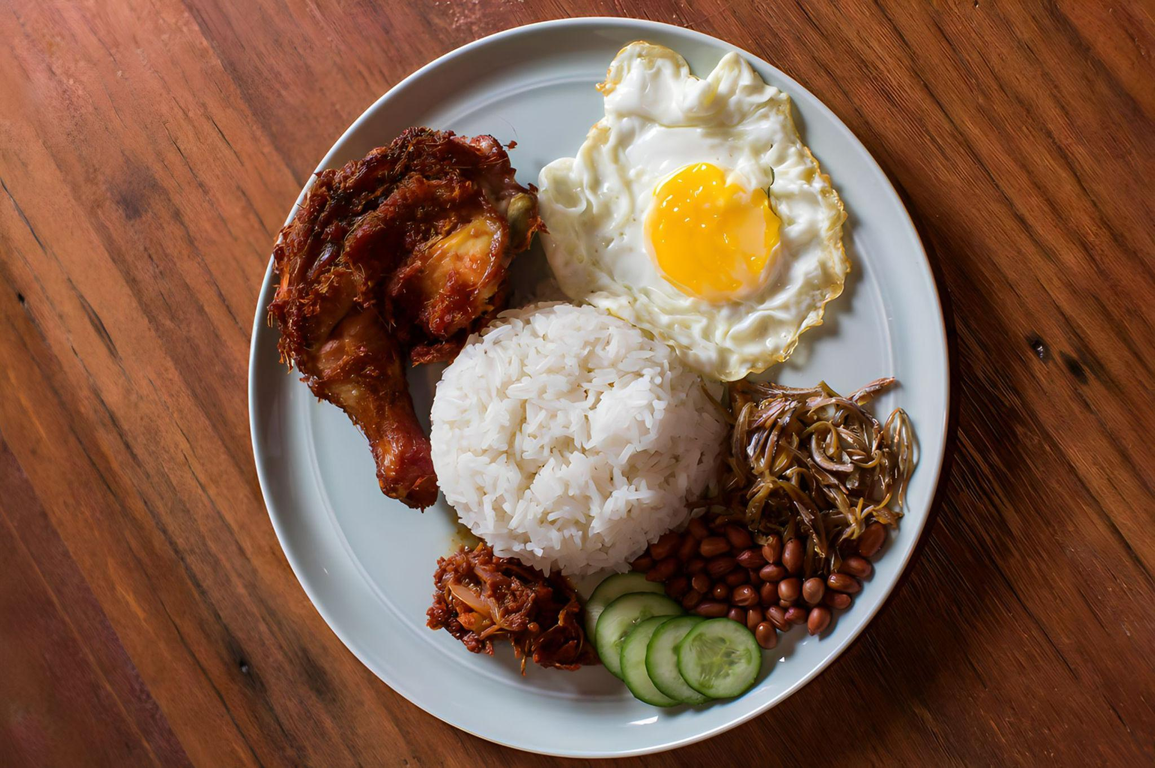
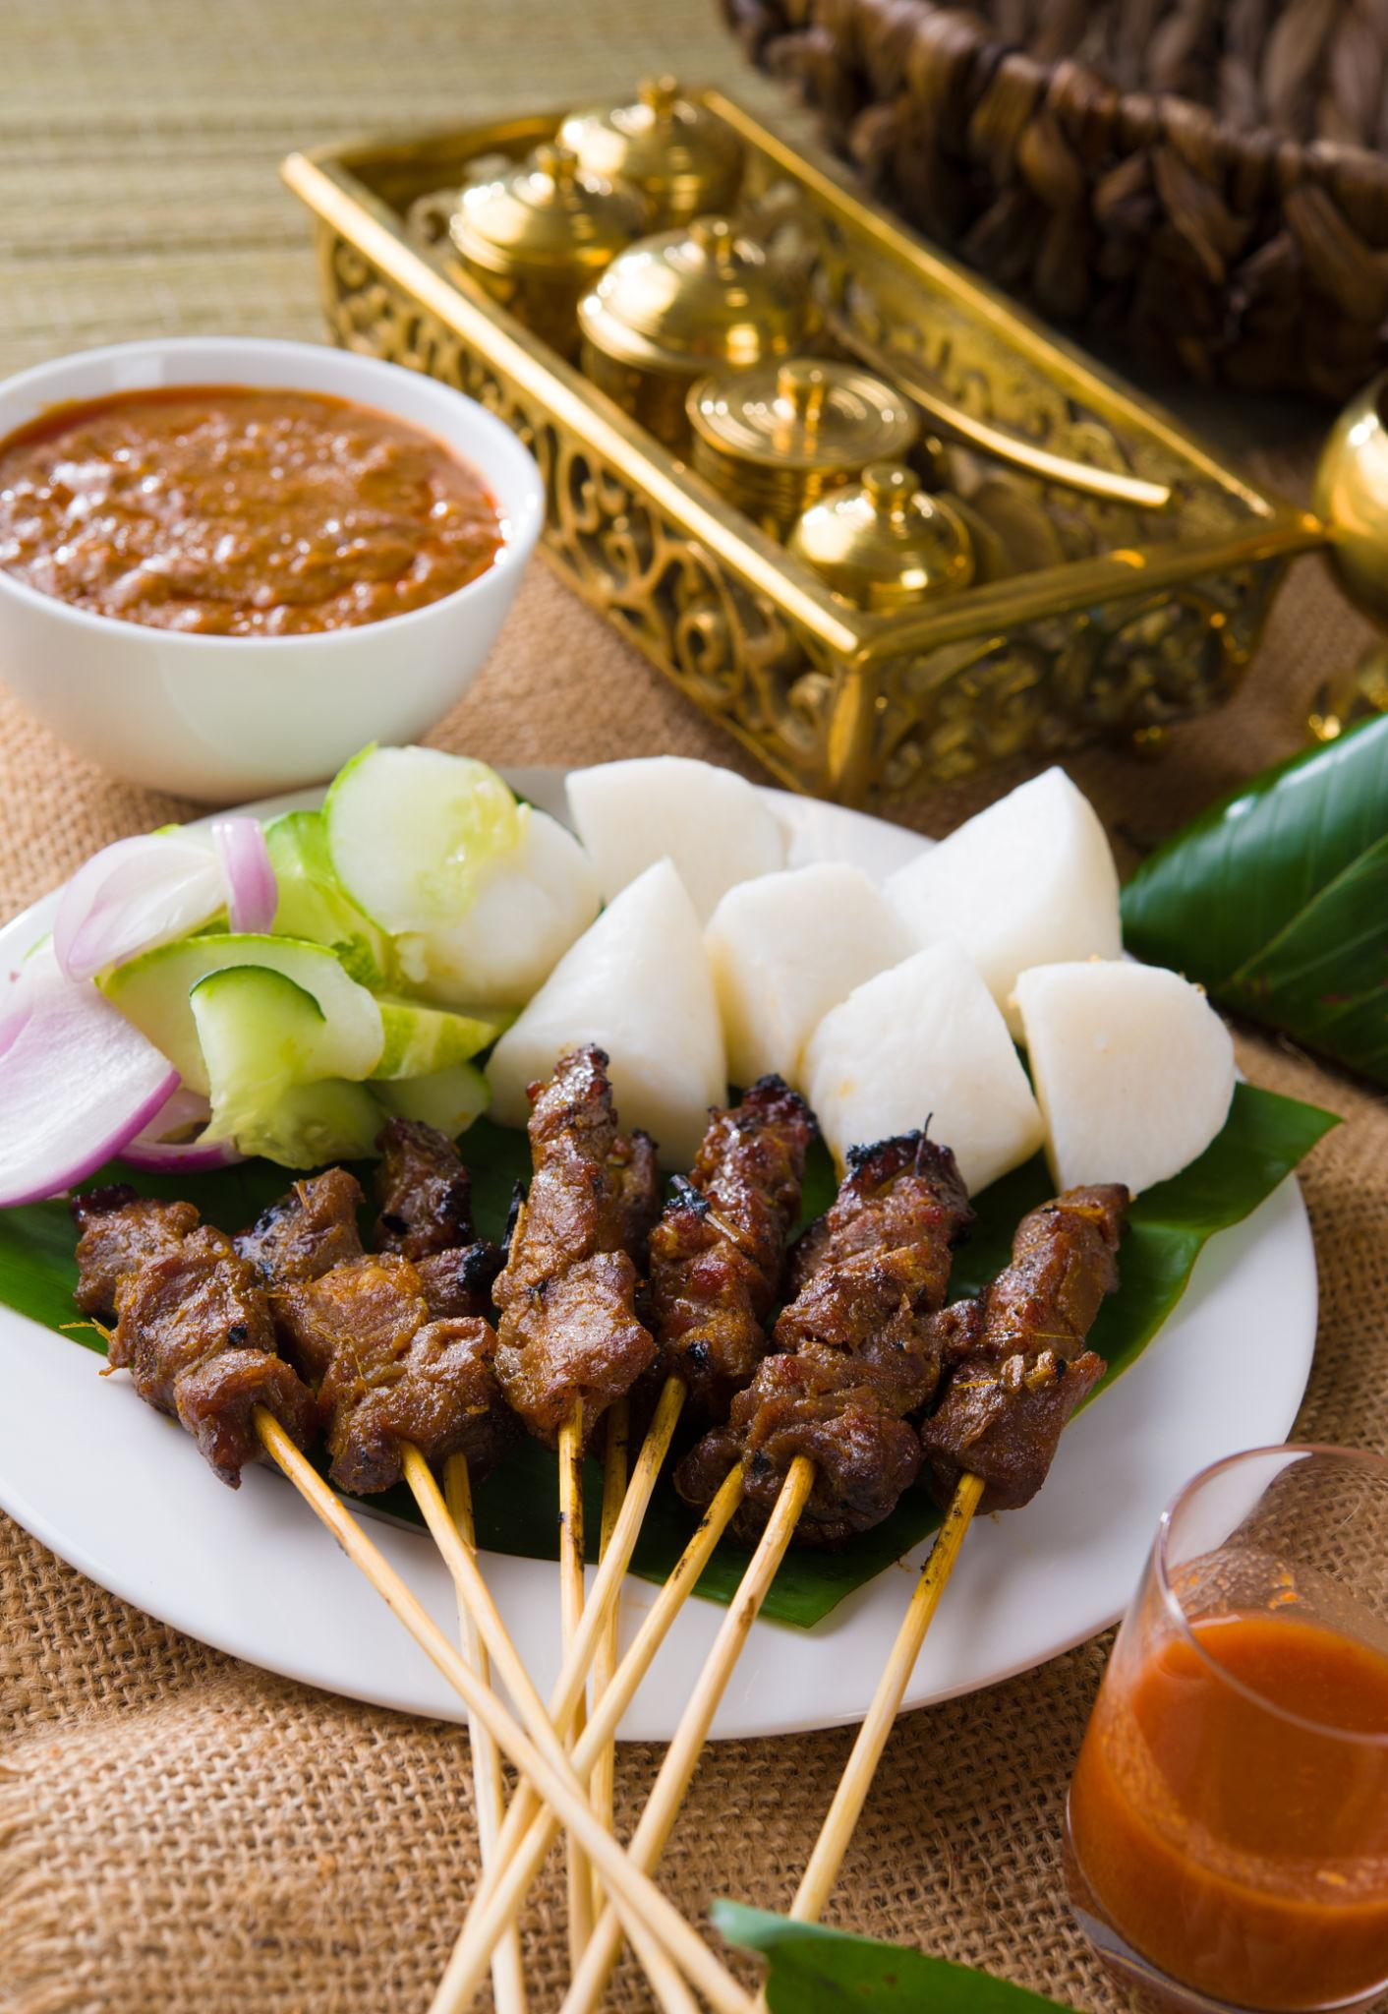

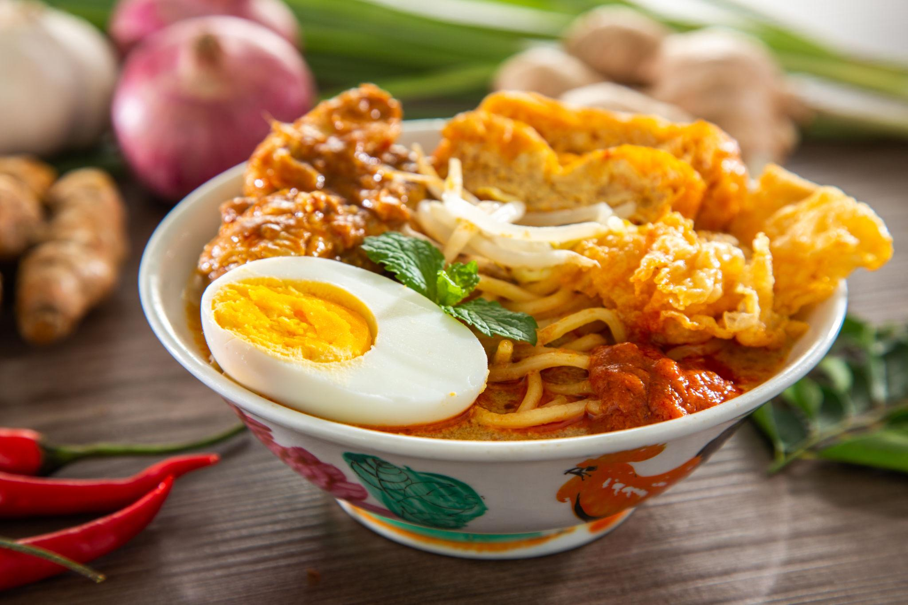
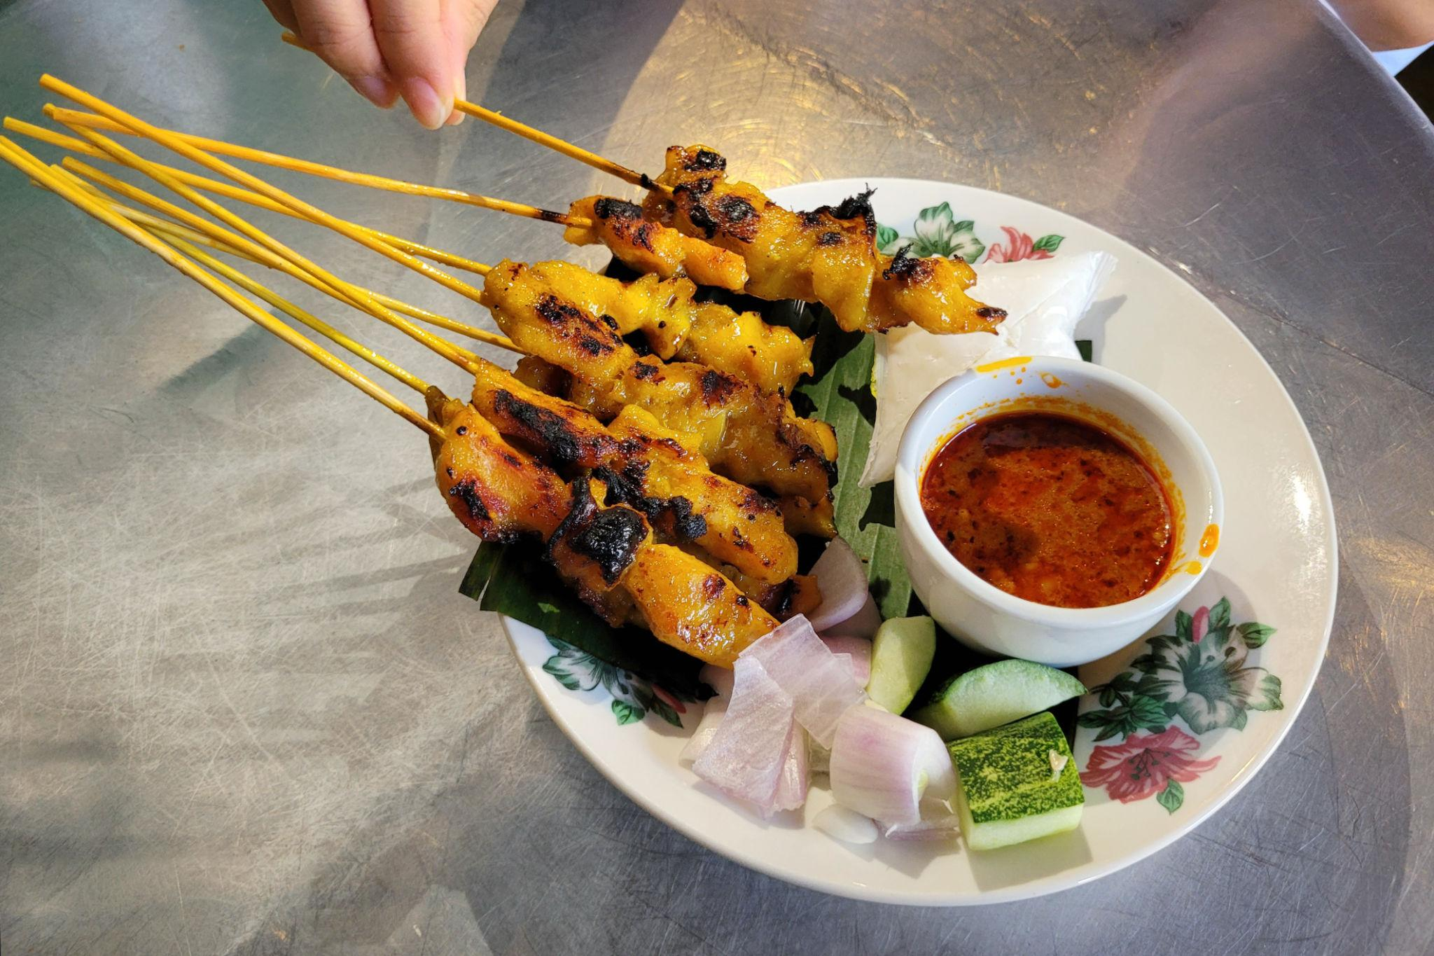

Luxury Experiences in Malaysia ✨
- Stay in luxury beach resorts
- Private island tours
- Helicopter sightseeing
- Fine dining with skyline views
- Spa & wellness retreats
- Sunset cruises in Langkawi
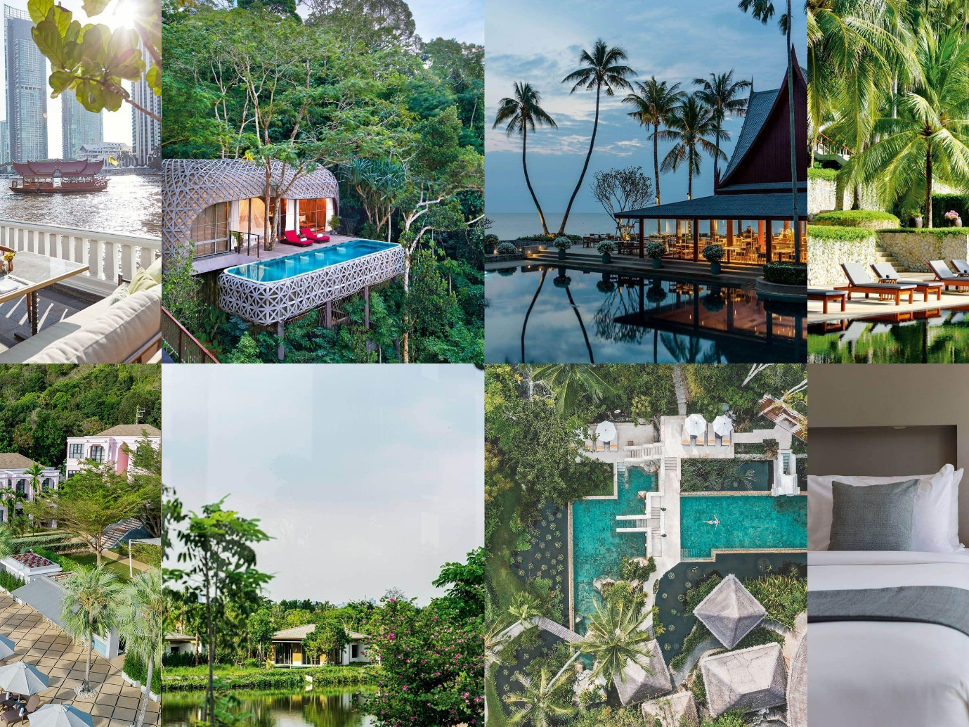

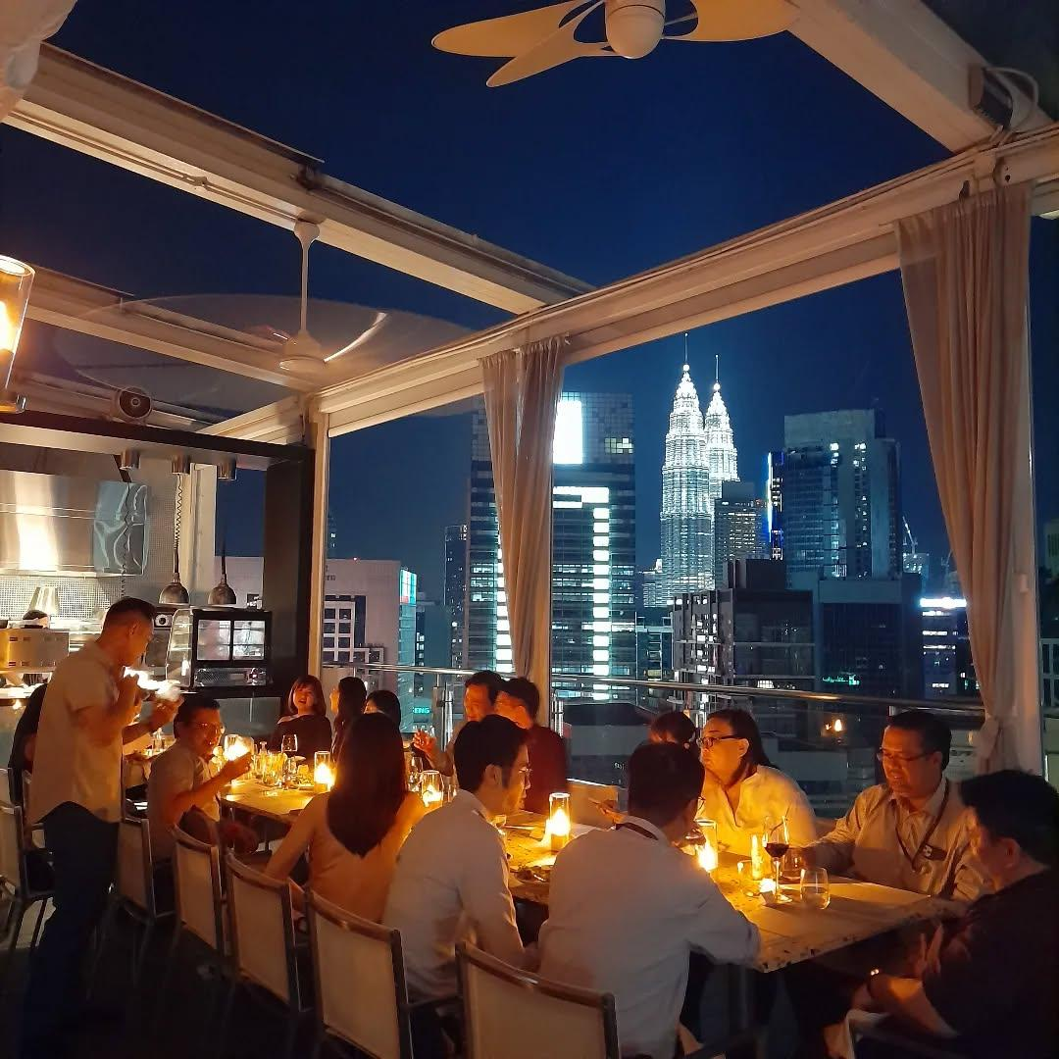
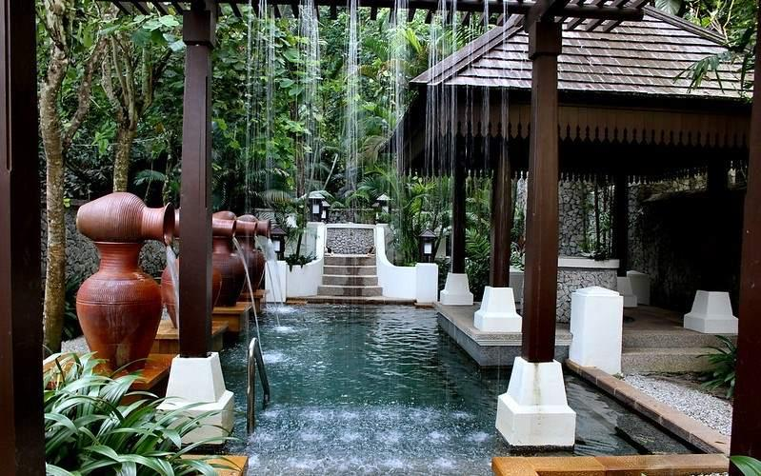

Malaysia Travel Tips
- Carry light cotton clothes
- Respect local cultural traditions
- Use Grab app for affordable transport
- Keep cash for local markets
- Stay hydrated in tropical weather
- Book attractions early during holidays

Why Choose INTRO TRAVELS INDIA for Malaysia?
With INTRO TRAVELS INDIA, you get:
- Customized Malaysia holiday packages
- Honeymoon & family tours
- Budget & luxury hotel options
- Visa assistance
- Airport transfers
- Guided sightseeing tours
- Indian meal options
- Group departures & private tours
Malaysia is a destination where modern luxury, tropical beauty, rich culture, and unforgettable adventures come together for the perfect international holiday.

